UNITED STATES
SECURITIES AND EXCHANGE COMMISSION
WASHINGTON, D.C. 20549
___________________________
FORM 8-K
___________________________
CURRENT REPORT
Pursuant to Section 13 or 15(d) of the Securities Exchange Act of 1934
Date of Report (Date of earliest event reported): October 19, 2026
___________________________
RBB BANCORP
(Exact name of Registrant as Specified in Its Charter)
___________________________
California |  |  | 001-38149 |  |  | 27-2776416
(State or Other Jurisdiction  of Incorporation) |  |  | (Commission  File Number) |  |  | (IRS Employer  Identification No.)
1055 Wilshire Blvd., 12th floor,  Los Angeles, California |  |  |  |  |  | 90017
(Address of Principal Executive Offices) |  |  |  |  |  | (Zip Code)
Registrant’s Telephone Number, Including Area Code: (213) 627-9888
Not Applicable
(Former Name or Former Address, if Changed Since Last Report)
___________________________
Check the appropriate box below if the Form 8-K filing is intended to simultaneously satisfy the filing obligation of the registrant under any of the following provisions (see General Instructions A.2. below):
o |  |  | Written communications pursuant to Rule 425 under the Securities Act (17 CFR 230.425)
o |  |  | Soliciting material pursuant to Rule 14a-12 under the Exchange Act (17 CFR 240.14a-12)
o |  |  | Pre-commencement communications pursuant to Rule 14d-2(b) under the Exchange Act (17 CFR 240.14d-2(b))
o |  |  | Pre-commencement communications pursuant to Rule 13e-4(c) under the Exchange Act (17 CFR 240.13e-4(c))
Securities registered pursuant to Section 12 (b) of the Act:
Title of each class |  |  |  |  |  | Trading  Symbol(s) |  |  |  |  |  | Name of exchange on which registered
Common Stock, No Par Value |  |  |  |  |  | RBB |  |  |  |  |  | NASDAQ Global Select Market
Indicate by check mark whether the registrant is an emerging growth company as defined in Rule 405 of the Securities Act of 1933 (§ 230.405 of this chapter) or Rule 12b-2 of the Securities Exchange Act of 1934 (§ 240.12b-2 of this chapter).
Emerging growth company o
If an emerging growth company, indicate by check mark if the registrant has elected not to use the extended transition period for complying with any new or revised financial accounting standards provided pursuant to Section 13(a) of the Exchange Act. o

Item 2.02 Results of Operations and Financial Condition.
On October 19, 2026, RBB Bancorp (the “Company”) issued a press release setting forth the financial results for the quarter ended September 30, 2026, and information relating to the Company’s quarterly conference call and webcast. A copy of this press release is attached hereto as Exhibit 99.1 and is incorporated by reference herein.
The information furnished under Item 2.02 and Exhibit 99.1 of Item 9.01 of this Current Report on Form 8-K shall not be deemed “filed” for the purposes of Section 18 of the Securities Exchange Act of 1934, as amended (the “Exchange Act”), or otherwise subject to the liabilities of such Section, nor shall such information be deemed incorporated by reference into any registration statement or other filings of the Company under the Securities Act of 1933, as amended (the “Securities Act”), except as shall be expressly set for by specific reference in such filing.

Item 7.01 Regulation FD Disclosure.
On October 20, 2026, the Company will hold a conference call to discuss its financial results for the quarter ended September 30, 2026, and other matters relating to the Company. The Company has also made available on its website, www.royalbusinessbankusa.com, presentation materials containing certain historical and forward-looking information relating to the Company (the “Presentation Materials”). The Presentation Materials are furnished as Exhibit 99.2 hereto and are incorporated by reference herein. All information in Exhibit 99.2 is presented as of the particular date or dates referenced therein, and the Company does not undertake any obligation to, and disclaims any duty to, update any of the information provided.
The information furnished under Item 7.01 and Item 9.01 of this Current Report on Form 8-K (including Exhibit 99.2) shall not be deemed “filed” for purposes of Section 18 of the Exchange Act, or otherwise subject to the liabilities of such Section, nor shall such information be deemed incorporated by reference into any registration statement or other filings of the Company under the Securities Act, except as otherwise expressly stated in such filing.

Item 8.01 Other Events.
On October 19, 2026, RBB Bancorp announced that its Board of Directors declared a cash dividend of $0.16 per share of its common stock, payable on November 12, 2026, to common shareholders of record as of October 30, 2026. A copy of the press release announcing the cash dividend described in this Item 8.01 is attached as Exhibit 99.1 hereto and incorporated by reference herein. The information contained in Exhibit 99.1 shall not be deemed “filed” for the purposes of Section 18 of the Exchange Act, or otherwise subject to the liabilities of such Section, nor shall such information and Exhibit be deemed incorporated by reference into any registration statement or other filings of the Company under the Securities Act, except as shall be expressly set forth by specific reference in such filing.

Item 9.01 Financial Statements and Exhibits.
(d) |  |  | Exhibits.
99.1 |  |  | Press Release, dated October 19, 2026, announcing the financial results of RBB Bancorp for the quarter ended September 30, 2026 and declaration of a quarterly cash dividend of $0.16 per common share
99.2 |  |  | Presentation Materials
104 |  |  | Cover Page Interactive Data File (embedded within the Inline XBRL document)

SIGNATURES
Pursuant to the requirements of the Securities Exchange Act of 1934, the registrant has duly caused this report to be signed on its behalf by the undersigned thereunto duly authorized.
RBB BANCORP
(Registrant)
Date: October 19, 2026 |  |  | By: |  |  | /s/ Lynn Hopkins
 |  |  |  |  |  | Lynn Hopkins
 |  |  |  |  |  | Chief Financial Officer

Exhibit 99.1

RBB Bancorp Reports Third Quarter 2026 Earnings and Declares Quarterly Cash Dividend of $0.16 Per Common Share
Los Angeles, CA, October 19, 2026 – RBB Bancorp (NASDAQ:RBB) and its bank subsidiary, Royal Business Bank (the “Bank”), collectively referred to herein as the “Company,” announced financial results for the quarter ended September 30, 2026.

Third Quarter 2026 Highlights
•Net income totaled $12.6 million, or $0.74 diluted earnings per share
•Return on average assets of 1.17%, compared to 0.97% for the prior quarter
•Net interest margin of 3.16%, up from 3.06% for the prior quarter
•Nonperforming assets of $38.7 million, a $4.9 million, or 11.3%, decrease compared to prior quarter end
•Book value and tangible book value per share(1) increased to $31.75 and $27.44 at September 30, 2026, up from $31.51 and $27.23 at June 30, 2026
•$2.7 million gain on the sale of an office building in Brooklyn, New York
•Partial redemption of subordinated notes of $40 million was completed on July 1, 2026
The Company reported net income of $12.6 million, or $0.74 diluted earnings per share, for the quarter ended September 30, 2026, compared to net income of $10.1 million, or $0.59 diluted earnings per share, for the quarter ended June 30, 2026.
“Our third quarter results reflected the continued strength of our core banking franchise as the partial redemption of our subordinated notes and the continued resolution of nonperforming assets contributed to higher net interest income," said Johnny Lee, President and Chief Executive Officer of RBB Bancorp. "We continued to improve the quality of our funding base through strong retail deposit growth, which allowed us to reduce our reliance on wholesale deposits. Credit quality continued to improve, with nonperforming assets declining 11% from the prior quarter. Strong loan production drove double-digit annualized loan growth in the quarter, and with healthy pipelines and business activity in our markets, we believe we are well positioned to continue these positive trends to finish the year."

Net Interest Income and Net Interest Margin
Net interest income was $31.8 million for the third quarter of 2026, compared to $30.1 million for the second quarter of 2026. The $1.7 million increase was due to a $2.1 million increase in interest income, partially offset by a $473,000 increase in interest expense. The increase in interest income was due to the combination of a $1.5 million increase in loan interest income as average loans and nonaccrual interest recoveries increased, one additional day in the quarter and a special dividend of $320,000 from the Federal Home Loan Bank ("FHLB") in the third quarter of 2026. There was no special dividend from the FHLB in the second quarter of 2026. The increase in interest expense was due mainly to a $239,000 increase in interest on total borrowings due to higher average balances partially offset by lower rates and a $234,000 increase in interest on deposits due mainly to one additional day in the quarter.
The net interest margin (“NIM”) increased 10 basis points to 3.16% for the third quarter of 2026 from 3.06% for the second quarter of 2026. The NIM increase included a 9 basis point increase in the yield on average total interest-earning assets and a 3 basis point decrease in the overall cost of funds. The yield on average total interest-earning assets increased to 5.90% for the third quarter of 2026 from 5.81% for the second quarter of 2026, due mostly to the impact of higher nonaccrual interest recoveries on loans and the FHLB special dividend received in the third quarter.
(1) Reconciliations of the non–U.S. generally accepted accounting principles (“GAAP”) measures included at the end of this press release.
1
The average total cost of funds decreased 3 basis points to 2.97% for the third quarter of 2026 from 3.00% for the second quarter of 2026, due mostly to a decrease in the cost of borrowings due to the partial redemption of $40.0 million of subordinated notes on July 1, 2026. Average noninterest-bearing deposits increased to approximately 17% of average total deposits for the third quarter of 2026 from 16% for the second quarter of 2026. The period end weighted average interest rate for total deposits increased to 2.82% at September 30, 2026 from 2.75% at June 30, 2026. The increase is due in part to the impact of the recent 25 basis point increase to the Federal funds rate.

Provision for Credit Losses
The provision for credit losses was $500,000 for the third quarter of 2026 compared to no provision for the second quarter of 2026. The third quarter 2026 provision for credit losses reflected a provision for loan losses of $500,000 and no provision for unfunded loan commitments. The third quarter provision for loan losses was due mainly to the impact of net loan growth, partially offset by improved credit quality trends and underlying economic forecast indicators. Net charge-offs in both the third quarter and second quarter of 2026 represented 0.01% of average loans on an annualized basis.

Noninterest Income
Noninterest income for the third quarter of 2026 was $5.1 million, an increase of $2.1 million from $3.0 million for the second quarter of 2026. The increase in noninterest income was mainly due to higher other income of $2.7 million, offset partially by lower gain on sale of loans of $875,000 due to lower sale volume. The increase in other income was primarily due to a $2.7 million gain on the sale of the Bank's office building in Brooklyn, New York. As part of the sale, the Bank entered into a four month lease to house its loan operations center through the end of 2026. These operations will relocate to new leased space, also located in Brooklyn, starting in 2027.

Noninterest Expense
Noninterest expense for the third quarter of 2026 was $19.5 million, an increase of $526,000 from $19.0 million for the second quarter of 2026. The increase was due mainly to higher salaries and benefits and occupancy costs. Both of these categories increased due to a full quarter of operations for the Northern California loan production office and occupancy costs also included rent for the Brooklyn loan operations center after the sale of the building. The efficiency ratio was 53.0% for the third quarter of 2026, compared to 57.5% for the second quarter of 2026. The improvement in the efficiency ratio is attributed mostly to higher net revenues.

Income Taxes
The effective tax rate was 24.9% for the third quarter of 2026 and 28.0% for the second quarter of 2026. The decrease in the effective tax rate for the third quarter of 2026 was due to higher benefits from purchased Federal tax credits recognized in the quarter. The effective tax rate for 2026 is estimated to be 26.9% compared to 24.2% for 2025. The estimated effective tax rate for 2026 is expected to be higher than the effective tax rate in 2025 due mainly to a higher multi-state blended tax rate and lower benefits from purchased Federal tax credits for the full year.

Balance Sheet
At September 30, 2026, total assets were $4.3 billion, a $23.7 million, or 2.2% annualized, decrease compared to total assets of $4.3 billion at June 30, 2026, and a $42.8 million, or 1.0%, increase compared to total assets of $4.2 billion at September 30, 2025.

Loan and Securities Portfolio
Loans held for investment ("HFI") totaled $3.4 billion as of September 30, 2026, an increase of $89.8 million, or 10.8% annualized, compared to June 30, 2026 and an increase of $96.6 million, or 2.9%, compared to September 30, 2025. The increase in loans in the third quarter of 2026 included $154.0 million of originations with an average yield of 6.30%, $30.5 million in advances, and $21.9 million in purchases, offset by payoffs/paydowns of $113.8 million and loans sold of $2.7 million. The loan to deposit ratio was 100.1% at September 30, 2026, compared to 97.6% at June 30, 2026 and 98.1% at September 30, 2025.
As of September 30, 2026, available for sale securities ("AFS") totaled $381.3 million, a decrease of $25.8 million from June 30, 2026, primarily related to maturities and paydowns of $52.7 million, offset by purchases of $36.4 million during the third quarter of 2026. As of September 30, 2026, net unrealized pre-tax losses totaled $30.6 million, a $9.7 million increase due to increased market interest rates when compared to net unrealized pre-tax losses of $20.9 million as of June 30, 2026.
2

Deposits
Total deposits were $3.4 billion as of September 30, 2026, an increase of $4.6 million, or 0.5% annualized, compared to June 30, 2026 and an increase of $28.8 million, or 0.9%, compared to September 30, 2025. The increase in total deposits during the third quarter of 2026 was due to a $63.3 million increase in retail deposits, offset by a $58.7 million decrease in wholesale deposits. The increase in retail deposits included a $46.5 million increase in non-maturity interest-bearing accounts and a $51.6 million increase in time deposits, offset by a $34.7 million decrease in demand deposits. Noninterest-bearing deposits totaled $556.8 million, or 16.4% of total deposits, at September 30, 2026, a decrease of $34.7 million compared to June 30, 2026, and an increase of $6.4 million compared to September 30, 2025.

Credit Quality
Nonperforming assets totaled $38.7 million, or 0.91% of total assets, at September 30, 2026, down from $43.6 million, or 1.02% of total assets, at June 30, 2026, and down from $54.3 million, or 1.29% of total assets, at September 30, 2025. The decrease in nonperforming assets during the third quarter of 2026 was due to a decrease of $4.9 million in nonperforming loans (“NPL”). Other real estate owned (“OREO”) totaled $19.8 million at September 30, 2026 and June 30, 2026, and $8.8 million at September 30, 2025.
NPLs totaled $18.8 million, or 0.55% of total loans, at September 30, 2026, down $4.9 million from $23.8 million, or 0.72% of total loans, at June 30, 2026 and down $26.6 million from $45.5 million, or 1.38% of total loans, at September 30, 2025. The $4.9 million decrease in NPLs during the third quarter of 2026 was due mostly to $5.3 million in payoffs/paydowns partially offset by additions of $522,000.
Substandard loans totaled $57.3 million, or 1.69% of total loans, at September 30, 2026, down from $61.5 million, or 1.86% of total loans, at June 30, 2026 and $76.9 million, or 2.33% of total loans, at September 30, 2025. The $4.2 million decrease in substandard loans during the third quarter of 2026 was primarily due to $5.4 million in payoffs/paydowns, partially offset by additions of $1.2 million. Of the total substandard loans outstanding at September 30, 2026, there were $38.5 million, or 67% of such loans, on accrual status.
Special mention loans totaled $24.3 million, or 0.72% of total loans, at September 30, 2026, up from $20.3 million, or 0.61% of total loans, at June 30, 2026, and down from $49.3 million, or 1.49% of total loans, at September 30, 2025. The $4.1 million increase for the third quarter of 2026 was primarily due to additions of $7.0 million, partially offset by payoffs/paydowns of $1.5 million, and upgrades of $1.4 million to pass-rated loans. As of September 30, 2026, all special mention loans are on accrual status.
30-89 day delinquent loans, excluding NPLs, totaled $7.2 million, or 0.21% of total loans, at September 30, 2026, down from $9.0 million, or 0.27% of total loans, at June 30, 2026, and up from $6.5 million, or 0.20% of total loans, at September 30, 2025. The $1.7 million decrease for the third quarter of 2026 was mainly due to $5.7 million in loans returning to current status, payoffs/paydowns of $0.7 million, and $0.5 million in loans which migrated to nonperforming, offset by $5.4 million in new delinquent loans.
As of September 30, 2026, the allowance for credit losses totaled $44.4 million and was comprised of an allowance for loan losses of $44.0 million and a reserve for unfunded loan commitments of $407,000 (included in “accrued interest and other liabilities”). This compares to the allowance for credit losses of $44.1 million, comprised of an allowance for loan losses of $43.7 million and a reserve for unfunded loan commitments of $407,000 at June 30, 2026. The $378,000 increase in the allowance for credit losses for the third quarter of 2026 was due to a provision for credit losses of $500,000 offset by net charge-offs of $122,000. The allowance for loan losses as a percentage of loans HFI totaled 1.30% at September 30, 2026, compared to 1.32% at June 30, 2026. The allowance for loan losses as a percentage of nonperforming loans HFI was 234% at September 30, 2026, up from 184% at June 30, 2026.
3
 |  |  | For the Three Months Ended September 30, 2026 |  |  |  |  |  |  |  |  |  |  |  |  |  |  |  |  |  | For the Nine Months Ended September 30, 2026
(dollars in thousands) |  |  | Allowance for loan losses |  |  |  |  |  | Reserve for unfunded loan commitments |  |  |  |  |  | Allowance for credit losses |  |  |  |  |  | Allowance for loan losses |  |  |  |  |  | Reserve for unfunded loan commitments |  |  |  |  |  | Allowance for credit losses
Beginning balance |  |  | $ | 43,660 |  |  |  |  | $ | 407 |  |  |  |  | $ | 44,067 |  |  |  |  | $ | 43,888 |  |  |  |  | $ | 484 |  |  |  |  | $ | 44,372
Provision for/(reversal of) credit losses |  |  | 500 |  |  |  |  |  | — |  |  |  |  |  | 500 |  |  |  |  |  | 377 |  |  |  |  |  | (77) |  |  |  |  |  | 300
Less loans charged-off |  |  | (137) |  |  |  |  |  | — |  |  |  |  |  | (137) |  |  |  |  |  | (283) |  |  |  |  |  | — |  |  |  |  |  | (283)
Recoveries on loans charged-off |  |  | 15 |  |  |  |  |  | — |  |  |  |  |  | 15 |  |  |  |  |  | 56 |  |  |  |  |  | — |  |  |  |  |  | 56
Ending balance |  |  | $ | 44,038 |  |  |  |  | $ | 407 |  |  |  |  | $ | 44,445 |  |  |  |  | $ | 44,038 |  |  |  |  | $ | 407 |  |  |  |  | $ | 44,445

Shareholders' Equity
At September 30, 2026, total shareholders' equity was $534.2 million, a $934,000 decrease compared to June 30, 2026, and a $19.9 million increase compared to September 30, 2025. The decrease in shareholders' equity for the third quarter of 2026 was due mostly to an increase in unrealized losses on AFS securities, net of tax, of $6.8 million, common stock repurchases of $4.5 million and common stock cash dividends paid of $2.7 million, offset by net income of $12.6 million and stock-based compensation activity of $450,000.

Dividend Announcement
The Board of Directors has declared a quarterly cash dividend of $0.16 per common share. The dividend is payable on November 12, 2026 to shareholders of record on October 30, 2026.

Contact:
Lynn Hopkins, Chief Financial Officer
(213) 716-8066
lhopkins@rbbusa.com

Corporate Overview
RBB Bancorp is a community-based financial holding company headquartered in Los Angeles, California. As of September 30, 2026, the Company had total assets of $4.3 billion. Its wholly-owned subsidiary, Royal Business Bank, is a full service commercial bank, which provides business banking products and services predominately to Asian-centric communities through 24 branches and one loan production office located in California, Nevada, New York, Illinois, New Jersey and Hawaii. Bank products and services include commercial and investor real estate loans, business loans and lines of credit, commercial and industrial loans, SBA 7A and 504 loans, 1-4 single family residential loans, trade finance, wealth management and a full range of depository accounts, including specialized services such as remote deposit, E-banking, mobile banking and treasury management services. The Bank has nine branches in Los Angeles County, two branches in Ventura County, one branch in Orange County, and one loan production office in the San Francisco Bay area in California; one branch in Las Vegas, Nevada; three branches and one loan operations center in Brooklyn, three branches in Queens, and one branch in Manhattan in New York; one branch in Edison, New Jersey; two branches in Chicago, Illinois; and, one branch in Honolulu, Hawaii. The Company's administrative and lending center is located at 1055 Wilshire Blvd., Los Angeles, California 90017, and its operations center is located at 7025 Orangethorpe Ave., Buena Park, California 90621. The Company's website address is www.royalbusinessbankusa.com.

Conference Call
Management will hold a conference call at 11:00 a.m. Pacific time/2:00 p.m. Eastern time on Tuesday, October 20, 2026, to discuss the Company’s third quarter 2026 financial results.
To listen to the conference call, please dial 1-888-506-0062 or 1-973-528-0011, the Participant ID code is 889260, conference ID RBBQ326. A replay of the call will be made available at 1-877-481-4010 or 1-919-882-2331, the passcode is 54597, approximately one hour after the conclusion of the call and will remain available through November 3, 2026.
4
The conference call will also be simultaneously webcast over the Internet; please visit our Royal Business Bank website at www.royalbusinessbankusa.com and click on the “Investors” tab to access the call from the site. This webcast will be recorded and available for replay on our website approximately two hours after the conclusion of the conference call.

Disclosure
This press release contains certain non-GAAP financial disclosures, which the Company uses to provide meaningful supplemental information regarding the Company’s operational performance and to enhance investors’ overall understanding of such financial performance. Please refer to the tables at the end of this press release for a presentation of performance ratios in accordance with GAAP and a reconciliation of the non-GAAP financial measures to the GAAP financial measures.

Safe Harbor
Certain matters set forth herein constitute forward-looking statements within the meaning of the Private Securities Litigation Reform Act of 1995, Section 27A of the Securities Act of 1933, as amended, and Section 21E of the Securities Exchange Act of 1934, as amended. Forward-looking statements include statements relating to the Company’s current business plans and expectations and our future financial position and operating results. These forward-looking statements are subject to risks and uncertainties that could cause actual results, performance and/or achievements to differ materially from those projected. These risks and uncertainties include, but are not limited to, business and economic conditions generally and in the financial services industry, nationally and within our current and future geographic markets, including ineffective management of the United States (“U.S.”) federal budget or debt or turbulence or uncertainty in domestic or foreign financial markets; the strength of the U.S. economy in general and the strength of the local economies in which we conduct operations; the impact of adverse developments in the banking industry, including bank failures and the potential impact of such developments on customer confidence, liquidity and regulatory responses to these developments; federal government shutdowns and uncertainty regarding the federal government’s debt limit; possible additional provisions for credit losses and charge-offs; credit risks of lending activities and deterioration in asset or credit quality; extensive laws and regulations and supervision that we are subject to, including potential supervisory action by bank supervisory authorities; compliance with the Bank Secrecy Act and other money laundering statutes and regulations; potential goodwill impairment; liquidity risk; failure to comply with debt covenants; fluctuations in interest rates; risks associated with acquisitions and the expansion of our business into new markets; inflation and deflation; real estate market conditions and the value of real estate collateral; the effects of having concentrations in our loan portfolio, including commercial real estate and the risks of geographic and industry concentrations; environmental liabilities; our ability to compete with larger competitors; our ability to retain key personnel; successful management of reputational risk; severe weather, natural disasters, earthquakes, fires, or other adverse external events could harm our business; geopolitical conditions, including acts or threats of terrorism, actions taken by the U.S. or other governments in response to acts or threats of terrorism and/or military conflicts, including the war between Russia and Ukraine, conflict in the Middle East, and increasing tensions between China and Taiwan, which could impact business and economic conditions in the U.S. and abroad; tariffs, trade policies, and related tensions, which could impact our clients, specific industry sectors, and/or broader economic conditions and financial market; public health crises and pandemics, and their effects on the economic and business environments in which we operate, including our credit quality and business operations, as well as the impact on general economic and financial market conditions; general economic or business conditions in Asia, and other regions where the Bank has operations; failures, interruptions, or security breaches of our information systems; climate change, including any enhanced regulatory, compliance, credit and reputational risks and costs; cybersecurity threats and the cost of defending against them; our ability to adapt our systems to the expanding use of technology in banking; risk management processes and strategies; the impact of regulatory enforcement actions, if any; certain provisions in our charter and bylaws that may affect acquisition of the Company; changes in tax laws and regulations; the impact of governmental efforts to restructure the U.S. financial regulatory system and increased costs of compliance and other risks associated with changes in regulation, including any amendments to the Dodd-Frank Wall Street Reform and Consumer Protection Act; the impact of changes in the Federal Deposit Insurance Corporation (“FDIC”) insurance assessment rate and the rules and regulations related to the calculation of the FDIC insurance assessments; the effect of changes in accounting policies and practices or accounting standards, as may be adopted from time-to-time by bank regulatory agencies, the U.S. Securities and Exchange Commission (“SEC”), the Public Company Accounting Oversight Board, the Financial Accounting Standards Board (FASB) or other accounting standards setters; fluctuations in the Company’s stock price; restrictions on dividends and other distributions by laws and regulations and by our regulators and our capital
5
structure; our ability to raise additional capital, if needed, and the potential resulting dilution of interests of holders of our common stock; the soundness of other financial institutions; our ongoing relations with our various federal and state regulators, including the SEC, FDIC, the Board of Governors of the Federal Reserve System, California Department of Financial Protection and Innovation, and Consumer Financial Protection Bureau; our success at managing the risks involved in the foregoing items and all other factors set forth in the Company’s public reports, including its Annual Report as filed under Form 10-K for the year ended December 31, 2025, and particularly the discussion of risk factors within that document. There can be no assurance that other factors not currently anticipated by us will not materially and adversely affect our business, financial condition and results of operations. Any statements about future operating results, such as those concerning accretion and dilution to the Company's earnings or shareholders, are for illustrative purposes only, are not forecasts, and actual results may differ. You are cautioned not to place undue reliance on our forward-looking statements, which reflect management's analysis and expectations only as of the date of such statements. The Company does not undertake, and specifically disclaims any obligation, to update any forward-looking statements to reflect occurrences or unanticipated events or circumstances after the date of such statements, except as required by law.

6
RBB BANCORP AND SUBSIDIARIES
CONDENSED CONSOLIDATED BALANCE SHEETS
(Unaudited)
(Dollars in thousands)
 |  |  | September 30,  2026 |  |  |  |  |  | June 30,  2026 |  |  |  |  |  | March 31,  2026 |  |  |  |  |  | December 31,  2025 |  |  |  |  |  | September 30,  2025
Assets
Cash and due from banks |  |  | $ | 24,697 |  |  |  |  | $ | 25,363 |  |  |  |  | $ | 23,893 |  |  |  |  | $ | 27,086 |  |  |  |  | $ | 24,251
Interest-earning deposits with financial institutions |  |  | 165,593 |  |  |  |  |  | 257,652 |  |  |  |  |  | 173,017 |  |  |  |  |  | 185,231 |  |  |  |  |  | 210,679
Cash and cash equivalents |  |  | 190,290 |  |  |  |  |  | 283,015 |  |  |  |  |  | 196,910 |  |  |  |  |  | 212,317 |  |  |  |  |  | 234,930
Interest-earning time deposits with financial institutions |  |  | 600 |  |  |  |  |  | 600 |  |  |  |  |  | 600 |  |  |  |  |  | 600 |  |  |  |  |  | 600
Investment securities available for sale |  |  | 381,344 |  |  |  |  |  | 407,160 |  |  |  |  |  | 415,789 |  |  |  |  |  | 407,204 |  |  |  |  |  | 410,631
Investment securities held to maturity |  |  | 4,179 |  |  |  |  |  | 4,181 |  |  |  |  |  | 4,182 |  |  |  |  |  | 4,184 |  |  |  |  |  | 4,185
Loans held for sale |  |  | — |  |  |  |  |  | — |  |  |  |  |  | — |  |  |  |  |  | 2,067 |  |  |  |  |  | 756
Loans held for investment |  |  | 3,399,214 |  |  |  |  |  | 3,309,459 |  |  |  |  |  | 3,325,232 |  |  |  |  |  | 3,314,301 |  |  |  |  |  | 3,302,577
Allowance for loan losses |  |  | (44,038) |  |  |  |  |  | (43,660) |  |  |  |  |  | (43,666) |  |  |  |  |  | (43,888) |  |  |  |  |  | (44,892)
Net loans held for investment |  |  | 3,355,176 |  |  |  |  |  | 3,265,799 |  |  |  |  |  | 3,281,566 |  |  |  |  |  | 3,270,413 |  |  |  |  |  | 3,257,685
Premises and equipment, net |  |  | 17,950 |  |  |  |  |  | 22,868 |  |  |  |  |  | 23,204 |  |  |  |  |  | 23,540 |  |  |  |  |  | 23,851
Federal Home Loan Bank (FHLB) stock |  |  | 15,000 |  |  |  |  |  | 15,000 |  |  |  |  |  | 15,000 |  |  |  |  |  | 15,000 |  |  |  |  |  | 15,000
Cash surrender value of bank owned life insurance |  |  | 63,290 |  |  |  |  |  | 62,841 |  |  |  |  |  | 62,403 |  |  |  |  |  | 61,972 |  |  |  |  |  | 61,538
Goodwill |  |  | 71,498 |  |  |  |  |  | 71,498 |  |  |  |  |  | 71,498 |  |  |  |  |  | 71,498 |  |  |  |  |  | 71,498
Net deferred tax assets |  |  | 18,174 |  |  |  |  |  | 15,115 |  |  |  |  |  | 15,242 |  |  |  |  |  | 16,347 |  |  |  |  |  | 14,935
Income tax receivable |  |  | 12,754 |  |  |  |  |  | 7,296 |  |  |  |  |  | 5,554 |  |  |  |  |  | 17,483 |  |  |  |  |  | 9,827
Right-of-use assets |  |  | 20,754 |  |  |  |  |  | 22,068 |  |  |  |  |  | 22,601 |  |  |  |  |  | 23,026 |  |  |  |  |  | 24,305
Accrued interest and other assets |  |  | 100,287 |  |  |  |  |  | 97,561 |  |  |  |  |  | 79,763 |  |  |  |  |  | 82,643 |  |  |  |  |  | 78,714
Total assets |  |  | $ | 4,251,296 |  |  |  |  | $ | 4,275,002 |  |  |  |  | $ | 4,194,312 |  |  |  |  | $ | 4,208,294 |  |  |  |  | $ | 4,208,455
Liabilities and shareholders' equity
Deposits:
Noninterest-bearing demand |  |  | $ | 556,848 |  |  |  |  | $ | 591,556 |  |  |  |  | $ | 526,882 |  |  |  |  | $ | 526,538 |  |  |  |  | $ | 550,488
Savings, NOW and money market accounts |  |  | 1,237,657 |  |  |  |  |  | 1,191,198 |  |  |  |  |  | 1,175,735 |  |  |  |  |  | 956,299 |  |  |  |  |  | 721,697
Time deposits, $250,000 and under |  |  | 755,509 |  |  |  |  |  | 815,528 |  |  |  |  |  | 863,717 |  |  |  |  |  | 974,670 |  |  |  |  |  | 1,119,258
Time deposits, greater than $250,000 |  |  | 845,266 |  |  |  |  |  | 792,359 |  |  |  |  |  | 773,550 |  |  |  |  |  | 892,891 |  |  |  |  |  | 975,054
Total deposits |  |  | 3,395,280 |  |  |  |  |  | 3,390,641 |  |  |  |  |  | 3,339,884 |  |  |  |  |  | 3,350,398 |  |  |  |  |  | 3,366,497
FHLB advances |  |  | 180,000 |  |  |  |  |  | 160,000 |  |  |  |  |  | 130,000 |  |  |  |  |  | 130,000 |  |  |  |  |  | 130,000
Long-term debt, net of issuance costs |  |  | 80,000 |  |  |  |  |  | 120,000 |  |  |  |  |  | 120,000 |  |  |  |  |  | 119,911 |  |  |  |  |  | 119,815
Subordinated debentures |  |  | 15,538 |  |  |  |  |  | 15,484 |  |  |  |  |  | 15,429 |  |  |  |  |  | 15,375 |  |  |  |  |  | 15,320
Lease liabilities - operating leases |  |  | 22,513 |  |  |  |  |  | 23,836 |  |  |  |  |  | 24,379 |  |  |  |  |  | 24,800 |  |  |  |  |  | 26,066
Accrued interest and other liabilities |  |  | 23,722 |  |  |  |  |  | 29,864 |  |  |  |  |  | 33,566 |  |  |  |  |  | 44,400 |  |  |  |  |  | 36,422
Total liabilities |  |  | 3,717,053 |  |  |  |  |  | 3,739,825 |  |  |  |  |  | 3,663,258 |  |  |  |  |  | 3,684,884 |  |  |  |  |  | 3,694,120
Shareholders' equity:
Common stock |  |  | 248,374 |  |  |  |  |  | 250,590 |  |  |  |  |  | 251,050 |  |  |  |  |  | 250,694 |  |  |  |  |  | 250,362
Additional paid-in capital |  |  | 3,199 |  |  |  |  |  | 3,004 |  |  |  |  |  | 3,649 |  |  |  |  |  | 3,941 |  |  |  |  |  | 3,734
Retained earnings |  |  | 303,994 |  |  |  |  |  | 296,119 |  |  |  |  |  | 290,566 |  |  |  |  |  | 282,024 |  |  |  |  |  | 274,608
Non-controlling interest |  |  | 72 |  |  |  |  |  | 72 |  |  |  |  |  | 72 |  |  |  |  |  | 72 |  |  |  |  |  | 72
Accumulated other comprehensive loss, net |  |  | (21,396) |  |  |  |  |  | (14,608) |  |  |  |  |  | (14,283) |  |  |  |  |  | (13,321) |  |  |  |  |  | (14,441)
Total shareholders' equity |  |  | 534,243 |  |  |  |  |  | 535,177 |  |  |  |  |  | 531,054 |  |  |  |  |  | 523,410 |  |  |  |  |  | 514,335
Total liabilities and shareholders’ equity |  |  | $ | 4,251,296 |  |  |  |  | $ | 4,275,002 |  |  |  |  | $ | 4,194,312 |  |  |  |  | $ | 4,208,294 |  |  |  |  | $ | 4,208,455

7
RBB BANCORP AND SUBSIDIARIES
CONDENSED CONSOLIDATED STATEMENTS OF INCOME
(Unaudited)
(In thousands, except share and per share data)
 |  |  | For the Three Months Ended |  |  |  |  |  |  |  |  |  |  |  |  |  |  |  |  |  | For the Nine Months Ended
 |  |  | September 30,  2026 |  |  |  |  |  | June 30,  2026 |  |  |  |  |  | September 30,  2025 |  |  |  |  |  | September 30,  2026 |  |  |  |  |  | September 30,  2025
Interest and dividend income:
Interest and fees on loans |  |  | $ | 52,200 |  |  |  |  | $ | 50,663 |  |  |  |  | $ | 50,094 |  |  |  |  | $ | 152,801 |  |  |  |  | $ | 143,402
Interest on interest-earning deposits |  |  | 2,296 |  |  |  |  |  | 1,708 |  |  |  |  |  | 2,140 |  |  |  |  |  | 5,887 |  |  |  |  |  | 5,904
Interest on investment securities |  |  | 4,027 |  |  |  |  |  | 4,259 |  |  |  |  |  | 4,592 |  |  |  |  |  | 12,255 |  |  |  |  |  | 12,941
Dividend income on FHLB stock |  |  | 539 |  |  |  |  |  | 222 |  |  |  |  |  | 327 |  |  |  |  |  | 1,521 |  |  |  |  |  | 981
Interest on federal funds sold and other |  |  | 245 |  |  |  |  |  | 307 |  |  |  |  |  | 239 |  |  |  |  |  | 805 |  |  |  |  |  | 705
Total interest and dividend income |  |  | 59,307 |  |  |  |  |  | 57,159 |  |  |  |  |  | 57,392 |  |  |  |  |  | 173,269 |  |  |  |  |  | 163,933
Interest expense:
Interest on savings deposits, NOW and money market accounts |  |  | 9,045 |  |  |  |  |  | 9,197 |  |  |  |  |  | 4,674 |  |  |  |  |  | 25,589 |  |  |  |  |  | 13,709
Interest on time deposits |  |  | 14,783 |  |  |  |  |  | 14,397 |  |  |  |  |  | 20,152 |  |  |  |  |  | 45,401 |  |  |  |  |  | 58,486
Interest on long-term debt and subordinated debentures |  |  | 1,749 |  |  |  |  |  | 2,428 |  |  |  |  |  | 1,635 |  |  |  |  |  | 5,776 |  |  |  |  |  | 4,901
Interest on FHLB advances |  |  | 1,969 |  |  |  |  |  | 1,051 |  |  |  |  |  | 1,654 |  |  |  |  |  | 4,153 |  |  |  |  |  | 4,063
Total interest expense |  |  | 27,546 |  |  |  |  |  | 27,073 |  |  |  |  |  | 28,115 |  |  |  |  |  | 80,919 |  |  |  |  |  | 81,159
Net interest income before provision for credit losses |  |  | 31,761 |  |  |  |  |  | 30,086 |  |  |  |  |  | 29,277 |  |  |  |  |  | 92,350 |  |  |  |  |  | 82,774
Provision for credit losses |  |  | 500 |  |  |  |  |  | — |  |  |  |  |  | 625 |  |  |  |  |  | 300 |  |  |  |  |  | 9,758
Net interest income after provision for credit losses |  |  | 31,261 |  |  |  |  |  | 30,086 |  |  |  |  |  | 28,652 |  |  |  |  |  | 92,050 |  |  |  |  |  | 73,016
Noninterest income:
Service charges and fees |  |  | 1,110 |  |  |  |  |  | 1,104 |  |  |  |  |  | 1,099 |  |  |  |  |  | 3,246 |  |  |  |  |  | 3,176
Gain on sale of loans |  |  | 89 |  |  |  |  |  | 964 |  |  |  |  |  | 260 |  |  |  |  |  | 1,377 |  |  |  |  |  | 699
Loan servicing fees, net of amortization |  |  | 525 |  |  |  |  |  | 533 |  |  |  |  |  | 564 |  |  |  |  |  | 1,562 |  |  |  |  |  | 1,693
Increase in cash surrender value of life insurance |  |  | 449 |  |  |  |  |  | 438 |  |  |  |  |  | 427 |  |  |  |  |  | 1,318 |  |  |  |  |  | 1,241
(Loss)/gain on OREO |  |  | — |  |  |  |  |  | (221) |  |  |  |  |  | — |  |  |  |  |  | 669 |  |  |  |  |  | —
Other income |  |  | 2,932 |  |  |  |  |  | 200 |  |  |  |  |  | 943 |  |  |  |  |  | 4,202 |  |  |  |  |  | 7,257
Total noninterest income |  |  | 5,105 |  |  |  |  |  | 3,018 |  |  |  |  |  | 3,293 |  |  |  |  |  | 12,374 |  |  |  |  |  | 14,066
Noninterest expense:
Salaries and employee benefits |  |  | 11,467 |  |  |  |  |  | 11,045 |  |  |  |  |  | 10,600 |  |  |  |  |  | 33,773 |  |  |  |  |  | 32,323
Occupancy and equipment expenses |  |  | 2,587 |  |  |  |  |  | 2,449 |  |  |  |  |  | 2,425 |  |  |  |  |  | 7,547 |  |  |  |  |  | 7,209
Data processing |  |  | 1,722 |  |  |  |  |  | 1,690 |  |  |  |  |  | 1,805 |  |  |  |  |  | 5,120 |  |  |  |  |  | 5,120
Legal and professional |  |  | 1,306 |  |  |  |  |  | 1,311 |  |  |  |  |  | 1,450 |  |  |  |  |  | 4,120 |  |  |  |  |  | 5,869
Office expenses |  |  | 394 |  |  |  |  |  | 377 |  |  |  |  |  | 444 |  |  |  |  |  | 1,130 |  |  |  |  |  | 1,257
Marketing and business promotion |  |  | 193 |  |  |  |  |  | 178 |  |  |  |  |  | 252 |  |  |  |  |  | 586 |  |  |  |  |  | 661
Insurance and regulatory assessments |  |  | 743 |  |  |  |  |  | 746 |  |  |  |  |  | 732 |  |  |  |  |  | 2,238 |  |  |  |  |  | 2,171
Core deposit premium |  |  | 126 |  |  |  |  |  | 127 |  |  |  |  |  | 172 |  |  |  |  |  | 387 |  |  |  |  |  | 516
Other expenses |  |  | 1,010 |  |  |  |  |  | 1,099 |  |  |  |  |  | 803 |  |  |  |  |  | 2,927 |  |  |  |  |  | 2,572
Total noninterest expense |  |  | 19,548 |  |  |  |  |  | 19,022 |  |  |  |  |  | 18,683 |  |  |  |  |  | 57,828 |  |  |  |  |  | 57,698
Income before income taxes |  |  | 16,818 |  |  |  |  |  | 14,082 |  |  |  |  |  | 13,262 |  |  |  |  |  | 46,596 |  |  |  |  |  | 29,384
Income tax expense |  |  | 4,181 |  |  |  |  |  | 3,942 |  |  |  |  |  | 3,114 |  |  |  |  |  | 12,519 |  |  |  |  |  | 7,613
Net income |  |  | $ | 12,637 |  |  |  |  | $ | 10,140 |  |  |  |  | $ | 10,148 |  |  |  |  | $ | 34,077 |  |  |  |  | $ | 21,771
Net income per share
8
Basic |  |  | $ | 0.75 |  |  |  |  | $ | 0.60 |  |  |  |  | $ | 0.59 |  |  |  |  | $ | 2.01 |  |  |  |  | $ | 1.24
Diluted |  |  | $ | 0.74 |  |  |  |  | $ | 0.59 |  |  |  |  | $ | 0.59 |  |  |  |  | $ | 1.99 |  |  |  |  | $ | 1.24
Cash dividends declared per common share |  |  | $ | 0.16 |  |  |  |  | $ | 0.16 |  |  |  |  | $ | 0.16 |  |  |  |  | $ | 0.48 |  |  |  |  | $ | 0.48
Weighted-average common shares outstanding
Basic |  |  | 16,910,452 |  |  |  |  |  | 17,011,624 |  |  |  |  |  | 17,225,702 |  |  |  |  |  | 16,994,716 |  |  |  |  |  | 17,564,835
Diluted |  |  | 17,027,686 |  |  |  |  |  | 17,141,742 |  |  |  |  |  | 17,301,627 |  |  |  |  |  | 17,114,113 |  |  |  |  |  | 17,621,599

9
RBB BANCORP AND SUBSIDIARIES
AVERAGE BALANCE SHEET AND NET INTEREST INCOME
(Unaudited)
 |  |  | For the Three Months Ended
 |  |  | September 30, 2026 |  |  |  |  |  |  |  |  |  |  |  |  |  |  |  |  |  | June 30, 2026 |  |  |  |  |  |  |  |  |  |  |  |  |  |  |  |  |  | September 30, 2025
 |  |  | Average |  |  |  |  |  | Interest |  |  |  |  |  | Yield / |  |  |  |  |  | Average |  |  |  |  |  | Interest |  |  |  |  |  | Yield / |  |  |  |  |  | Average |  |  |  |  |  | Interest |  |  |  |  |  | Yield /
(tax-equivalent basis, dollars in thousands) |  |  | Balance |  |  |  |  |  | & Fees |  |  |  |  |  | Rate |  |  |  |  |  | Balance |  |  |  |  |  | & Fees |  |  |  |  |  | Rate |  |  |  |  |  | Balance |  |  |  |  |  | & Fees |  |  |  |  |  | Rate
Interest-earning assets
Cash and cash equivalents (1) |  |  | $ | 253,494 |  |  |  |  | $ | 2,541 |  |  |  |  | 3.98 |  | % |  |  |  | $ | 194,256 |  |  |  |  | $ | 2,015 |  |  |  |  | 4.16 |  | % |  |  |  | $ | 202,317 |  |  |  |  | $ | 2,380 |  |  |  |  | 4.67 |  | %
FHLB Stock |  |  | 15,000 |  |  |  |  |  | 539 |  |  |  |  |  | 14.26 |  | % |  |  |  | 15,000 |  |  |  |  |  | 222 |  |  |  |  |  | 5.94 |  | % |  |  |  | 15,000 |  |  |  |  |  | 327 |  |  |  |  |  | 8.65 |  | %
Securities
Available for sale (2) |  |  | 388,267 |  |  |  |  |  | 4,013 |  |  |  |  |  | 4.10 |  | % |  |  |  | 419,191 |  |  |  |  |  | 4,245 |  |  |  |  |  | 4.06 |  | % |  |  |  | 429,936 |  |  |  |  |  | 4,578 |  |  |  |  |  | 4.22 |  | %
Held to maturity (2) |  |  | 4,180 |  |  |  |  |  | 38 |  |  |  |  |  | 3.61 |  | % |  |  |  | 4,182 |  |  |  |  |  | 38 |  |  |  |  |  | 3.64 |  | % |  |  |  | 4,186 |  |  |  |  |  | 38 |  |  |  |  |  | 3.60 |  | %
Total loans (3) |  |  | 3,326,368 |  |  |  |  |  | 52,200 |  |  |  |  |  | 6.23 |  | % |  |  |  | 3,315,864 |  |  |  |  |  | 50,663 |  |  |  |  |  | 6.13 |  | % |  |  |  | 3,245,193 |  |  |  |  |  | 50,094 |  |  |  |  |  | 6.12 |  | %
Total interest-earning assets |  |  | 3,987,309 |  |  |  |  |  | $ | 59,331 |  |  |  |  | 5.90 |  | % |  |  |  | 3,948,493 |  |  |  |  |  | $ | 57,183 |  |  |  |  | 5.81 |  | % |  |  |  | 3,896,632 |  |  |  |  |  | $ | 57,417 |  |  |  |  | 5.85 |  | %
Total noninterest-earning assets |  |  | 279,828 |  |  |  |  |  |  |  |  |  |  |  |  |  |  |  |  |  | 262,546 |  |  |  |  |  |  |  |  |  |  |  |  |  |  |  |  |  | 255,052
Total average assets |  |  | $ | 4,267,137 |  |  |  |  |  |  |  |  |  |  |  |  |  |  |  |  | $ | 4,211,039 |  |  |  |  |  |  |  |  |  |  |  |  |  |  |  |  | $ | 4,151,684
Interest-bearing liabilities
NOW |  |  | $ | 91,562 |  |  |  |  | $ | 549 |  |  |  |  | 2.38 |  | % |  |  |  | $ | 83,681 |  |  |  |  | $ | 478 |  |  |  |  | 2.29 |  | % |  |  |  | $ | 69,800 |  |  |  |  | $ | 406 |  |  |  |  | 2.31 |  | %
Money market |  |  | 585,542 |  |  |  |  |  | 4,513 |  |  |  |  |  | 3.06 |  | % |  |  |  | 556,084 |  |  |  |  |  | 4,189 |  |  |  |  |  | 3.02 |  | % |  |  |  | 491,561 |  |  |  |  |  | 3,861 |  |  |  |  |  | 3.12 |  | %
Savings deposits |  |  | 521,545 |  |  |  |  |  | 3,983 |  |  |  |  |  | 3.03 |  | % |  |  |  | 589,187 |  |  |  |  |  | 4,529 |  |  |  |  |  | 3.08 |  | % |  |  |  | 138,344 |  |  |  |  |  | 407 |  |  |  |  |  | 1.17 |  | %
Time deposits, $250,000 and under |  |  | 796,245 |  |  |  |  |  | 7,011 |  |  |  |  |  | 3.49 |  | % |  |  |  | 837,026 |  |  |  |  |  | 7,322 |  |  |  |  |  | 3.51 |  | % |  |  |  | 1,050,682 |  |  |  |  |  | 10,312 |  |  |  |  |  | 3.89 |  | %
Time deposits, greater than $250,000 |  |  | 826,196 |  |  |  |  |  | 7,772 |  |  |  |  |  | 3.73 |  | % |  |  |  | 768,027 |  |  |  |  |  | 7,076 |  |  |  |  |  | 3.70 |  | % |  |  |  | 960,094 |  |  |  |  |  | 9,840 |  |  |  |  |  | 4.07 |  | %
Total interest-bearing deposits |  |  | 2,821,090 |  |  |  |  |  | 23,828 |  |  |  |  |  | 3.35 |  | % |  |  |  | 2,834,005 |  |  |  |  |  | 23,594 |  |  |  |  |  | 3.34 |  | % |  |  |  | 2,710,481 |  |  |  |  |  | 24,826 |  |  |  |  |  | 3.63 |  | %
FHLB advances |  |  | 197,174 |  |  |  |  |  | 1,969 |  |  |  |  |  | 3.96 |  | % |  |  |  | 116,813 |  |  |  |  |  | 1,051 |  |  |  |  |  | 3.61 |  | % |  |  |  | 185,217 |  |  |  |  |  | 1,654 |  |  |  |  |  | 3.54 |  | %
Long-term debt |  |  | 80,000 |  |  |  |  |  | 1,434 |  |  |  |  |  | 7.11 |  | % |  |  |  | 120,000 |  |  |  |  |  | 2,118 |  |  |  |  |  | 7.08 |  | % |  |  |  | 119,752 |  |  |  |  |  | 1,295 |  |  |  |  |  | 4.29 |  | %
Subordinated debentures |  |  | 15,502 |  |  |  |  |  | 315 |  |  |  |  |  | 8.06 |  | % |  |  |  | 15,448 |  |  |  |  |  | 310 |  |  |  |  |  | 8.05 |  | % |  |  |  | 15,284 |  |  |  |  |  | 340 |  |  |  |  |  | 8.83 |  | %
Total borrowings |  |  | 292,676 |  |  |  |  |  | 3,718 |  |  |  |  |  | 5.04 |  | % |  |  |  | 252,261 |  |  |  |  |  | 3,479 |  |  |  |  |  | 5.53 |  | % |  |  |  | 320,253 |  |  |  |  |  | 3,289 |  |  |  |  |  | 4.07 |  | %
Total interest-bearing liabilities |  |  | 3,113,766 |  |  |  |  |  | 27,546 |  |  |  |  |  | 3.51 |  | % |  |  |  | 3,086,266 |  |  |  |  |  | 27,073 |  |  |  |  |  | 3.52 |  | % |  |  |  | 3,030,734 |  |  |  |  |  | 28,115 |  |  |  |  |  | 3.68 |  | %
Noninterest-bearing liabilities
Noninterest-bearing deposits |  |  | 564,033 |  |  |  |  |  |  |  |  |  |  |  |  |  |  |  |  |  | 535,756 |  |  |  |  |  |  |  |  |  |  |  |  |  |  |  |  |  | 541,083
Other noninterest-bearing liabilities |  |  | 52,345 |  |  |  |  |  |  |  |  |  |  |  |  |  |  |  |  |  | 56,608 |  |  |  |  |  |  |  |  |  |  |  |  |  |  |  |  |  | 66,993
Total noninterest-bearing liabilities |  |  | 616,378 |  |  |  |  |  |  |  |  |  |  |  |  |  |  |  |  |  | 592,364 |  |  |  |  |  |  |  |  |  |  |  |  |  |  |  |  |  | 608,076
Shareholders' equity |  |  | 536,993 |  |  |  |  |  |  |  |  |  |  |  |  |  |  |  |  |  | 532,409 |  |  |  |  |  |  |  |  |  |  |  |  |  |  |  |  |  | 512,874
Total liabilities and shareholders' equity |  |  | $ | 4,267,137 |  |  |  |  |  |  |  |  |  |  |  |  |  |  |  |  | $ | 4,211,039 |  |  |  |  |  |  |  |  |  |  |  |  |  |  |  |  | $ | 4,151,684
Net interest income / interest rate spreads |  |  |  |  |  |  |  |  | $ | 31,785 |  |  |  |  | 2.39 |  | % |  |  |  |  |  |  |  |  |  | $ | 30,110 |  |  |  |  | 2.29 |  | % |  |  |  |  |  |  |  |  |  | $ | 29,302 |  |  |  |  | 2.17 |  | %
10
Net interest margin |  |  |  |  |  |  |  |  |  |  |  |  |  |  | 3.16 |  | % |  |  |  |  |  |  |  |  |  |  |  |  |  |  |  | 3.06 |  | % |  |  |  |  |  |  |  |  |  |  |  |  |  |  |  | 2.98 |  | %
Total cost of deposits |  |  | $ | 3,385,123 |  |  |  |  | $ | 23,828 |  |  |  |  | 2.79 |  | % |  |  |  | $ | 3,369,761 |  |  |  |  | $ | 23,594 |  |  |  |  | 2.81 |  | % |  |  |  | $ | 3,251,564 |  |  |  |  | $ | 24,826 |  |  |  |  | 3.03 |  | %
Total cost of funds |  |  | $ | 3,677,799 |  |  |  |  | $ | 27,546 |  |  |  |  | 2.97 |  | % |  |  |  | $ | 3,622,022 |  |  |  |  | $ | 27,073 |  |  |  |  | 3.00 |  | % |  |  |  | $ | 3,571,817 |  |  |  |  | $ | 28,115 |  |  |  |  | 3.12 |  | %
(1)Includes income and average balances for interest-earning time deposits and other miscellaneous interest-earning assets.
(2)Interest income and average rates for tax-exempt securities are presented on a tax-equivalent basis.
(3)Average loan balances relate to loans held for investment and loans held for sale and include nonaccrual loans. Interest income on loans includes the effects of discount accretion and net deferred loan origination fees and costs accounted for as yield adjustments.
11
RBB BANCORP AND SUBSIDIARIES
AVERAGE BALANCE SHEET AND NET INTEREST INCOME
(Unaudited)
 |  |  | For the Nine Months Ended September 30,
 |  |  | 2026 |  |  |  |  |  |  |  |  |  |  |  |  |  |  |  |  |  | 2025
 |  |  | Average |  |  |  |  |  | Interest |  |  |  |  |  | Yield / |  |  |  |  |  | Average |  |  |  |  |  | Interest |  |  |  |  |  | Yield /
(tax-equivalent basis, dollars in thousands) |  |  | Balance |  |  |  |  |  | & Fees |  |  |  |  |  | Rate |  |  |  |  |  | Balance |  |  |  |  |  | & Fees |  |  |  |  |  | Rate
Interest-earning assets
Cash and cash equivalents (1) |  |  | $ | 221,364 |  |  |  |  | $ | 6,692 |  |  |  |  | 4.04 |  | % |  |  |  | $ | 186,827 |  |  |  |  | $ | 6,609 |  |  |  |  | 4.73 |  | %
FHLB Stock |  |  | 15,000 |  |  |  |  |  | 1,521 |  |  |  |  |  | 13.56 |  | % |  |  |  | 15,000 |  |  |  |  |  | 981 |  |  |  |  |  | 8.74 |  | %
Securities
Available for sale (2) |  |  | 403,963 |  |  |  |  |  | 12,214 |  |  |  |  |  | 4.04 |  | % |  |  |  | 406,655 |  |  |  |  |  | 12,880 |  |  |  |  |  | 4.23 |  | %
Held to maturity (2) |  |  | 4,182 |  |  |  |  |  | 113 |  |  |  |  |  | 3.61 |  | % |  |  |  | 4,797 |  |  |  |  |  | 135 |  |  |  |  |  | 3.76 |  | %
Total loans (3) |  |  | 3,312,910 |  |  |  |  |  | 152,801 |  |  |  |  |  | 6.17 |  | % |  |  |  | 3,165,937 |  |  |  |  |  | 143,402 |  |  |  |  |  | 6.06 |  | %
Total interest-earning assets |  |  | 3,957,419 |  |  |  |  |  | $ | 173,341 |  |  |  |  | 5.86 |  | % |  |  |  | 3,779,216 |  |  |  |  |  | $ | 164,007 |  |  |  |  | 5.80 |  | %
Total noninterest-earning assets |  |  | 270,171 |  |  |  |  |  |  |  |  |  |  |  |  |  |  |  |  |  | 256,509
Total average assets |  |  | $ | 4,227,590 |  |  |  |  |  |  |  |  |  |  |  |  |  |  |  |  | $ | 4,035,725
Interest-bearing liabilities
NOW |  |  | $ | 83,026 |  |  |  |  | $ | 1,425 |  |  |  |  | 2.29 |  | % |  |  |  | $ | 65,957 |  |  |  |  | $ | 1,095 |  |  |  |  | 2.22 |  | %
Money market |  |  | 557,087 |  |  |  |  |  | 12,497 |  |  |  |  |  | 3.00 |  | % |  |  |  | 479,328 |  |  |  |  |  | 11,260 |  |  |  |  |  | 3.14 |  | %
Savings deposits |  |  | 517,579 |  |  |  |  |  | 11,667 |  |  |  |  |  | 3.01 |  | % |  |  |  | 144,895 |  |  |  |  |  | 1,354 |  |  |  |  |  | 1.25 |  | %
Time deposits, $250,000 and under |  |  | 852,689 |  |  |  |  |  | 22,645 |  |  |  |  |  | 3.55 |  | % |  |  |  | 1,012,408 |  |  |  |  |  | 30,126 |  |  |  |  |  | 3.98 |  | %
Time deposits, greater than $250,000 |  |  | 813,265 |  |  |  |  |  | 22,756 |  |  |  |  |  | 3.74 |  | % |  |  |  | 916,162 |  |  |  |  |  | 28,360 |  |  |  |  |  | 4.14 |  | %
Total interest-bearing deposits |  |  | 2,823,646 |  |  |  |  |  | 70,990 |  |  |  |  |  | 3.36 |  | % |  |  |  | 2,618,750 |  |  |  |  |  | 72,195 |  |  |  |  |  | 3.69 |  | %
FHLB advances |  |  | 148,242 |  |  |  |  |  | 4,153 |  |  |  |  |  | 3.75 |  | % |  |  |  | 173,810 |  |  |  |  |  | 4,063 |  |  |  |  |  | 3.13 |  | %
Long-term debt |  |  | 106,502 |  |  |  |  |  | 4,841 |  |  |  |  |  | 6.08 |  | % |  |  |  | 119,658 |  |  |  |  |  | 3,887 |  |  |  |  |  | 4.34 |  | %
Subordinated debentures |  |  | 15,449 |  |  |  |  |  | 935 |  |  |  |  |  | 8.09 |  | % |  |  |  | 15,230 |  |  |  |  |  | 1,014 |  |  |  |  |  | 8.90 |  | %
Total borrowings |  |  | 270,193 |  |  |  |  |  | 9,929 |  |  |  |  |  | 4.91 |  | % |  |  |  | 308,698 |  |  |  |  |  | 8,964 |  |  |  |  |  | 3.88 |  | %
Total interest-bearing liabilities |  |  | 3,093,839 |  |  |  |  |  | 80,919 |  |  |  |  |  | 3.50 |  | % |  |  |  | 2,927,448 |  |  |  |  |  | 81,159 |  |  |  |  |  | 3.71 |  | %
Noninterest-bearing liabilities
Noninterest-bearing deposits |  |  | 542,119 |  |  |  |  |  |  |  |  |  |  |  |  |  |  |  |  |  | 529,190
Other noninterest-bearing liabilities |  |  | 58,677 |  |  |  |  |  |  |  |  |  |  |  |  |  |  |  |  |  | 66,142
Total noninterest-bearing liabilities |  |  | 600,796 |  |  |  |  |  |  |  |  |  |  |  |  |  |  |  |  |  | 595,332
Shareholders' equity |  |  | 532,955 |  |  |  |  |  |  |  |  |  |  |  |  |  |  |  |  |  | 512,945
Total liabilities and shareholders' equity |  |  | $ | 4,227,590 |  |  |  |  |  |  |  |  |  |  |  |  |  |  |  |  | $ | 4,035,725
Net interest income / interest rate spreads |  |  |  |  |  |  |  |  | $ | 92,422 |  |  |  |  | 2.36 |  | % |  |  |  |  |  |  |  |  |  | $ | 82,848 |  |  |  |  | 2.09 |  | %
12
Net interest margin |  |  |  |  |  |  |  |  |  |  |  |  |  |  | 3.12 |  | % |  |  |  |  |  |  |  |  |  |  |  |  |  |  |  | 2.93 |  | %
Total cost of deposits |  |  | $ | 3,365,765 |  |  |  |  | $ | 70,990 |  |  |  |  | 2.82 |  | % |  |  |  | $ | 3,147,940 |  |  |  |  | $ | 72,195 |  |  |  |  | 3.07 |  | %
Total cost of funds |  |  | $ | 3,635,958 |  |  |  |  | $ | 80,919 |  |  |  |  | 2.98 |  | % |  |  |  | $ | 3,456,638 |  |  |  |  | $ | 81,159 |  |  |  |  | 3.14 |  | %
(1)Includes income and average balances for interest-earning time deposits and other miscellaneous interest-earning assets.
(2)Interest income and average rates for tax-exempt securities are presented on a tax-equivalent basis.
(3)Average loan balances relate to loans held for investment and loans held for sale and include nonaccrual loans. Interest income on loans includes the effects of discount accretion and net deferred loan origination fees and costs accounted for as yield adjustments.

13
RBB BANCORP AND SUBSIDIARIES
SELECTED FINANCIAL HIGHLIGHTS
(Unaudited)

 |  |  | At or for the Three Months Ended |  |  |  |  |  |  |  |  |  |  |  |  |  |  |  |  |  | At or for the Nine Months Ended September 30,
 |  |  | September 30,  2026 |  |  |  |  |  | June 30,  2026 |  |  |  |  |  | September 30,  2025 |  |  |  |  |  | 2026 |  |  |  |  |  | 2025
Per share data (common stock)
Book value |  |  | $ | 31.75 |  |  |  |  | $ | 31.51 |  |  |  |  | $ | 30.18 |  |  |  |  | $ | 31.75 |  |  |  |  | $ | 30.18
Tangible book value (1) |  |  | $ | 27.44 |  |  |  |  | $ | 27.23 |  |  |  |  | $ | 25.89 |  |  |  |  | $ | 27.44 |  |  |  |  | $ | 25.89
Performance ratios
Return on average assets, annualized |  |  | 1.17 |  | % |  |  |  | 0.97 |  | % |  |  |  | 0.97 |  | % |  |  |  | 1.08 |  | % |  |  |  | 0.72 |  | %
Return on average shareholders' equity, annualized |  |  | 9.34 |  | % |  |  |  | 7.64 |  | % |  |  |  | 7.85 |  | % |  |  |  | 8.55 |  | % |  |  |  | 5.67 |  | %
Return on average tangible common equity, annualized (1) |  |  | 10.79 |  | % |  |  |  | 8.85 |  | % |  |  |  | 9.16 |  | % |  |  |  | 9.90 |  | % |  |  |  | 6.62 |  | %
Noninterest income to average assets, annualized |  |  | 0.47 |  | % |  |  |  | 0.29 |  | % |  |  |  | 0.31 |  | % |  |  |  | 0.39 |  | % |  |  |  | 0.47 |  | %
Noninterest expense to average assets, annualized |  |  | 1.82 |  | % |  |  |  | 1.81 |  | % |  |  |  | 1.79 |  | % |  |  |  | 1.83 |  | % |  |  |  | 1.91 |  | %
Yield on average earning assets |  |  | 5.90 |  | % |  |  |  | 5.81 |  | % |  |  |  | 5.85 |  | % |  |  |  | 5.86 |  | % |  |  |  | 5.80 |  | %
Yield on average loans |  |  | 6.23 |  | % |  |  |  | 6.13 |  | % |  |  |  | 6.12 |  | % |  |  |  | 6.17 |  | % |  |  |  | 6.06 |  | %
Cost of average total deposits (2) |  |  | 2.79 |  | % |  |  |  | 2.81 |  | % |  |  |  | 3.03 |  | % |  |  |  | 2.82 |  | % |  |  |  | 3.07 |  | %
Cost of average interest-bearing deposits |  |  | 3.35 |  | % |  |  |  | 3.34 |  | % |  |  |  | 3.63 |  | % |  |  |  | 3.36 |  | % |  |  |  | 3.69 |  | %
Cost of average interest-bearing liabilities |  |  | 3.51 |  | % |  |  |  | 3.52 |  | % |  |  |  | 3.68 |  | % |  |  |  | 3.50 |  | % |  |  |  | 3.71 |  | %
Net interest spread |  |  | 2.39 |  | % |  |  |  | 2.29 |  | % |  |  |  | 2.17 |  | % |  |  |  | 2.36 |  | % |  |  |  | 2.09 |  | %
Net interest margin |  |  | 3.16 |  | % |  |  |  | 3.06 |  | % |  |  |  | 2.98 |  | % |  |  |  | 3.12 |  | % |  |  |  | 2.93 |  | %
Efficiency ratio (3) |  |  | 53.02 |  | % |  |  |  | 57.46 |  | % |  |  |  | 57.36 |  | % |  |  |  | 55.22 |  | % |  |  |  | 59.58 |  | %
Common stock dividend payout ratio |  |  | 21.33 |  | % |  |  |  | 26.67 |  | % |  |  |  | 27.12 |  | % |  |  |  | 23.88 |  | % |  |  |  | 38.71 |  | %
(1)Non-GAAP measure. See Non–GAAP reconciliations set forth at the end of this press release.
(2)Total deposits include noninterest-bearing deposits and interest-bearing deposits.
(3)Ratio calculated by dividing noninterest expense by the sum of net interest income before provision for credit losses and noninterest income.
14
RBB BANCORP AND SUBSIDIARIES
SELECTED FINANCIAL HIGHLIGHTS
(Unaudited)
(Dollars in thousands)

 |  |  | At or for the quarter ended
 |  |  | September 30,  2026 |  |  |  |  |  | June 30,  2026 |  |  |  |  |  | September 30,  2025
Credit Quality Data:
Special mention loans |  |  | $ | 24,328 |  |  |  |  | $ | 20,275 |  |  |  |  | $ | 49,349
Special mention loans to total loans HFI |  |  | 0.72 |  | % |  |  |  | 0.61 |  | % |  |  |  | 1.49 |  | %
Substandard loans HFI |  |  | $ | 57,326 |  |  |  |  | $ | 61,529 |  |  |  |  | $ | 76,880
Substandard loans HFI to total loans HFI |  |  | 1.69 |  | % |  |  |  | 1.86 |  | % |  |  |  | 2.33 |  | %
Loans 30-89 days past due, excluding nonperforming loans |  |  | $ | 7,229 |  |  |  |  | $ | 8,970 |  |  |  |  | $ | 6,533
Loans 30-89 days past due, excluding nonperforming loans, to total loans |  |  | 0.21 |  | % |  |  |  | 0.27 |  | % |  |  |  | 0.20 |  | %
Nonperforming loans HFI |  |  | $ | 18,835 |  |  |  |  | $ | 23,759 |  |  |  |  | $ | 45,484
OREO (included in "accrued interest and other assets") |  |  | 19,820 |  |  |  |  |  | 19,820 |  |  |  |  |  | 8,830
Nonperforming assets |  |  | $ | 38,655 |  |  |  |  | $ | 43,579 |  |  |  |  | $ | 54,314
Nonperforming loans to total loans HFI |  |  | 0.55 |  | % |  |  |  | 0.72 |  | % |  |  |  | 1.38 |  | %
Nonperforming assets to total assets |  |  | 0.91 |  | % |  |  |  | 1.02 |  | % |  |  |  | 1.29 |  | %
Allowance for loan losses |  |  | $ | 44,038 |  |  |  |  | $ | 43,660 |  |  |  |  | $ | 44,892
Allowance for loan losses to total loans HFI |  |  | 1.30 |  | % |  |  |  | 1.32 |  | % |  |  |  | 1.36 |  | %
Allowance for loan losses to nonperforming loans HFI |  |  | 233.81 |  | % |  |  |  | 183.76 |  | % |  |  |  | 98.70 |  | %
Net charge-offs |  |  | $ | 122 |  |  |  |  | $ | 83 |  |  |  |  | $ | 6,872
Net charge-offs to average loans |  |  | 0.01 |  | % |  |  |  | 0.01 |  | % |  |  |  | 0.84 |  | %
Capital ratios (1)
Tangible common equity to tangible assets (2) |  |  | 11.05 |  | % |  |  |  | 11.01 |  | % |  |  |  | 10.67 |  | %
Tier 1 leverage ratio |  |  | 11.82 |  | % |  |  |  | 11.86 |  | % |  |  |  | 11.50 |  | %
Tier 1 common capital to risk-weighted assets |  |  | 17.87 |  | % |  |  |  | 18.00 |  | % |  |  |  | 17.28 |  | %
Tier 1 capital to risk-weighted assets |  |  | 18.43 |  | % |  |  |  | 18.57 |  | % |  |  |  | 17.85 |  | %
Total capital to risk-weighted assets |  |  | 22.05 |  | % |  |  |  | 23.44 |  | % |  |  |  | 23.64 |  | %
(1)September 30, 2026 capital ratios are preliminary.
(2)Non-GAAP measure. See non-GAAP reconciliations set forth at the end of this press release.
15
RBB BANCORP AND SUBSIDIARIES
SELECTED FINANCIAL HIGHLIGHTS
(Unaudited)
Loan Portfolio Detail |  |  | As of September 30, 2026 |  |  |  |  |  |  |  |  |  |  |  | As of June 30, 2026 |  |  |  |  |  |  |  |  |  |  |  | As of September 30, 2025
(dollars in thousands) |  |  | $ |  |  |  |  |  | % |  |  |  |  |  | $ |  |  |  |  |  | % |  |  |  |  |  | $ |  |  |  |  |  | %
Loans:
Single-family residential mortgages |  |  | $ | 1,761,352 |  |  |  |  | 51.8 |  | % |  |  |  | $ | 1,680,635 |  |  |  |  | 50.8 |  | % |  |  |  | $ | 1,650,989 |  |  |  |  | 50.0 |  | %
Commercial real estate (1) |  |  | 1,280,028 |  |  |  |  |  | 37.7 |  | % |  |  |  | 1,277,559 |  |  |  |  |  | 38.6 |  | % |  |  |  | 1,286,603 |  |  |  |  |  | 39.0 |  | %
Construction and land development |  |  | 154,620 |  |  |  |  |  | 4.5 |  | % |  |  |  | 146,273 |  |  |  |  |  | 4.4 |  | % |  |  |  | 159,152 |  |  |  |  |  | 4.8 |  | %
Commercial and industrial |  |  | 151,796 |  |  |  |  |  | 4.5 |  | % |  |  |  | 151,961 |  |  |  |  |  | 4.6 |  | % |  |  |  | 146,667 |  |  |  |  |  | 4.4 |  | %
SBA |  |  | 48,525 |  |  |  |  |  | 1.4 |  | % |  |  |  | 49,667 |  |  |  |  |  | 1.5 |  | % |  |  |  | 54,033 |  |  |  |  |  | 1.6 |  | %
Other loans |  |  | 2,893 |  |  |  |  |  | 0.1 |  | % |  |  |  | 3,364 |  |  |  |  |  | 0.1 |  | % |  |  |  | 5,133 |  |  |  |  |  | 0.2 |  | %
Total loans held for investment |  |  | $ | 3,399,214 |  |  |  |  | 100.0 |  | % |  |  |  | $ | 3,309,459 |  |  |  |  | 100.0 |  | % |  |  |  | $ | 3,302,577 |  |  |  |  | 100.0 |  | %
Allowance for loan losses |  |  | (44,038) |  |  |  |  |  |  |  |  |  |  |  | (43,660) |  |  |  |  |  |  |  |  |  |  |  | (44,892)
Total loans held for investment, net |  |  | $ | 3,355,176 |  |  |  |  |  |  |  |  |  |  | $ | 3,265,799 |  |  |  |  |  |  |  |  |  |  | $ | 3,257,685
(1)Includes non-farm and non-residential loans, multi-family residential loans and non-owner occupied single family residential loans.
Deposits |  |  | As of September 30, 2026 |  |  |  |  |  |  |  |  |  |  |  | As of June 30, 2026 |  |  |  |  |  |  |  |  |  |  |  | As of September 30, 2025
(dollars in thousands) |  |  | $ |  |  |  |  |  | % |  |  |  |  |  | $ |  |  |  |  |  | % |  |  |  |  |  | $ |  |  |  |  |  | %
Deposits:
Noninterest-bearing demand |  |  | $ | 556,848 |  |  |  |  | 16.4 |  | % |  |  |  | $ | 591,556 |  |  |  |  | 17.5 |  | % |  |  |  | $ | 550,488 |  |  |  |  | 16.4 |  | %
Savings, NOW and money market accounts |  |  | 1,237,657 |  |  |  |  |  | 36.5 |  | % |  |  |  | 1,191,198 |  |  |  |  |  | 35.1 |  | % |  |  |  | 721,697 |  |  |  |  |  | 21.4 |  | %
Time deposits, $250,000 and under |  |  | 734,757 |  |  |  |  |  | 21.6 |  | % |  |  |  | 736,102 |  |  |  |  |  | 21.7 |  | % |  |  |  | 872,463 |  |  |  |  |  | 25.9 |  | %
Time deposits, greater than $250,000 |  |  | 804,500 |  |  |  |  |  | 23.7 |  | % |  |  |  | 751,600 |  |  |  |  |  | 22.2 |  | % |  |  |  | 953,785 |  |  |  |  |  | 28.3 |  | %
Wholesale deposits (1) |  |  | 61,518 |  |  |  |  |  | 1.8 |  | % |  |  |  | 120,185 |  |  |  |  |  | 3.5 |  | % |  |  |  | 268,064 |  |  |  |  |  | 8.0 |  | %
Total deposits |  |  | $ | 3,395,280 |  |  |  |  | 100.0 |  | % |  |  |  | $ | 3,390,641 |  |  |  |  | 100.0 |  | % |  |  |  | $ | 3,366,497 |  |  |  |  | 100.0 |  | %
(1)Includes brokered deposits, collateralized deposits from the State of California, and deposits acquired through internet listing services.

16
Non-GAAP Reconciliations

Tangible Book Value Reconciliations
Tangible book value per share is a non-GAAP disclosure. Management measures tangible book value per share to assess the Company’s capital strength and business performance and believes this is helpful to investors as an additional tool for further understanding our performance. The following is a reconciliation of tangible book value to the Company shareholders’ equity computed in accordance with GAAP, as well as a calculation of tangible book value per share as of the dates indicated.
(dollars in thousands, except share and per share data) |  |  | September 30, 2026 |  |  |  |  |  | June 30, 2026 |  |  |  |  |  | September 30, 2025
Tangible common equity:
Total shareholders' equity |  |  | $ | 534,243 |  |  |  |  | $ | 535,177 |  |  |  |  | $ | 514,335
Adjustments
Goodwill |  |  | (71,498) |  |  |  |  |  | (71,498) |  |  |  |  |  | (71,498)
Core deposit intangible |  |  | (951) |  |  |  |  |  | (1,078) |  |  |  |  |  | (1,495)
Tangible common equity |  |  | $ | 461,794 |  |  |  |  | $ | 462,601 |  |  |  |  | $ | 441,342
Tangible assets:
Total assets-GAAP |  |  | $ | 4,251,296 |  |  |  |  | $ | 4,275,002 |  |  |  |  | $ | 4,208,455
Adjustments
Goodwill |  |  | (71,498) |  |  |  |  |  | (71,498) |  |  |  |  |  | (71,498)
Core deposit intangible |  |  | (951) |  |  |  |  |  | (1,078) |  |  |  |  |  | (1,495)
Tangible assets |  |  | $ | 4,178,847 |  |  |  |  | $ | 4,202,426 |  |  |  |  | $ | 4,135,462
Common shares outstanding |  |  | 16,827,168 |  |  |  |  |  | 16,985,919 |  |  |  |  |  | 17,043,897
Common equity to assets ratio |  |  | 12.57 |  | % |  |  |  | 12.52 |  | % |  |  |  | 12.22 |  | %
Tangible common equity to tangible assets ratio |  |  | 11.05 |  | % |  |  |  | 11.01 |  | % |  |  |  | 10.67 |  | %
Book value per share |  |  | $ | 31.75 |  |  |  |  | $ | 31.51 |  |  |  |  | $ | 30.18
Tangible book value per share |  |  | $ | 27.44 |  |  |  |  | $ | 27.23 |  |  |  |  | $ | 25.89

Return on Average Tangible Common Equity
Management measures return on average tangible common equity (“ROATCE”) to assess the Company’s capital strength and business performance and believes this is helpful to investors as an additional tool for further understanding our performance. Tangible equity excludes goodwill and other intangible assets (excluding mortgage servicing rights) and is reviewed by banking and financial institution regulators when assessing a financial institution’s capital adequacy. This non-GAAP financial measure should not be considered a substitute for operating results determined in accordance with GAAP and may not be comparable to other similarly titled measures used by other companies. The following table reconciles ROATCE to its most comparable GAAP measure:
 |  |  | Three Months Ended |  |  |  |  |  |  |  |  |  |  |  |  |  |  |  |  |  | Nine Months Ended September 30,
(dollars in thousands) |  |  | September 30,  2026 |  |  |  |  |  | June 30,  2026 |  |  |  |  |  | September 30,  2025 |  |  |  |  |  | 2026 |  |  |  |  |  | 2025
Net income available to common shareholders |  |  | $ | 12,637 |  |  |  |  | $ | 10,140 |  |  |  |  | $ | 10,148 |  |  |  |  | $ | 34,077 |  |  |  |  | $ | 21,771
Average shareholders' equity |  |  | 536,993 |  |  |  |  |  | 532,409 |  |  |  |  |  | 512,874 |  |  |  |  |  | 532,955 |  |  |  |  |  | 512,945
Adjustments:
Average goodwill |  |  | (71,498) |  |  |  |  |  | (71,498) |  |  |  |  |  | (71,498) |  |  |  |  |  | (71,498) |  |  |  |  |  | (71,498)
Average core deposit intangible |  |  | (1,035) |  |  |  |  |  | (1,161) |  |  |  |  |  | (1,608) |  |  |  |  |  | (1,160) |  |  |  |  |  | (1,779)
Adjusted average tangible common equity |  |  | $ | 464,460 |  |  |  |  | $ | 459,750 |  |  |  |  | $ | 439,768 |  |  |  |  | $ | 460,297 |  |  |  |  | $ | 439,668
Return on average common equity, annualized |  |  | 9.34 |  | % |  |  |  | 7.64 |  | % |  |  |  | 7.85 |  | % |  |  |  | 8.55 |  | % |  |  |  | 5.67 |  | %
Return on average tangible common equity, annualized |  |  | 10.79 |  | % |  |  |  | 8.85 |  | % |  |  |  | 9.16 |  | % |  |  |  | 9.90 |  | % |  |  |  | 6.62 |  | %

17
Pre-Tax Pre-Provision Income
Management believes that pre-tax pre-provision (“PTPP”) income is a useful measure for investors to evaluate core operating performance, excluding the volatility of credit provision expenses. This non-GAAP financial measure should not be considered a substitute for operating results determined in accordance with GAAP and may not be comparable to other similarly titled measures used by other companies. PTPP income is calculated by subtracting noninterest expense from the sum of net interest income and noninterest income, as shown in the following table.
 |  |  | Three Months Ended |  |  |  |  |  |  |  |  |  |  |  |  |  |  |  |  |  | Nine Months Ended September 30,
(dollars in thousands) |  |  | September 30,  2026 |  |  |  |  |  | June 30,  2026 |  |  |  |  |  | September 30,  2025 |  |  |  |  |  | 2026 |  |  |  |  |  | 2025
Net interest income before provision for credit losses |  |  | $ | 31,761 |  |  |  |  | $ | 30,086 |  |  |  |  | $ | 29,277 |  |  |  |  | $ | 92,350 |  |  |  |  | $ | 82,774
Add: Noninterest income |  |  | 5,105 |  |  |  |  |  | 3,018 |  |  |  |  |  | 3,293 |  |  |  |  |  | 12,374 |  |  |  |  |  | 14,066
Less: Noninterest expense |  |  | (19,548) |  |  |  |  |  | (19,022) |  |  |  |  |  | (18,683) |  |  |  |  |  | (57,828) |  |  |  |  |  | (57,698)
Pre-tax pre-provision income |  |  | $ | 17,318 |  |  |  |  | $ | 14,082 |  |  |  |  | $ | 13,887 |  |  |  |  | $ | 46,896 |  |  |  |  | $ | 39,142
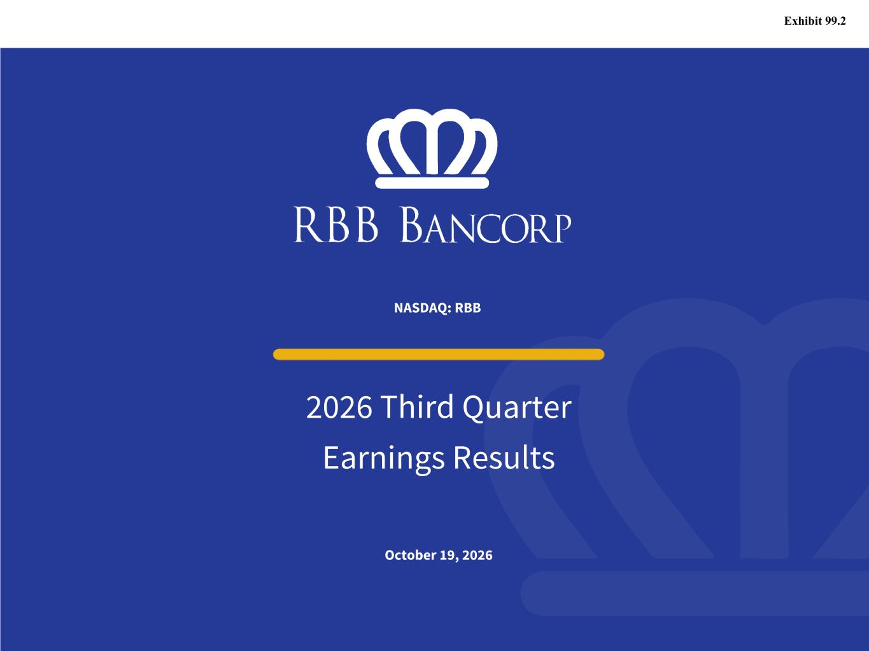
18
October 19, 2026 2026 Third Quarter Earnings Results NASDAQ: RBB Exhibit 99.2

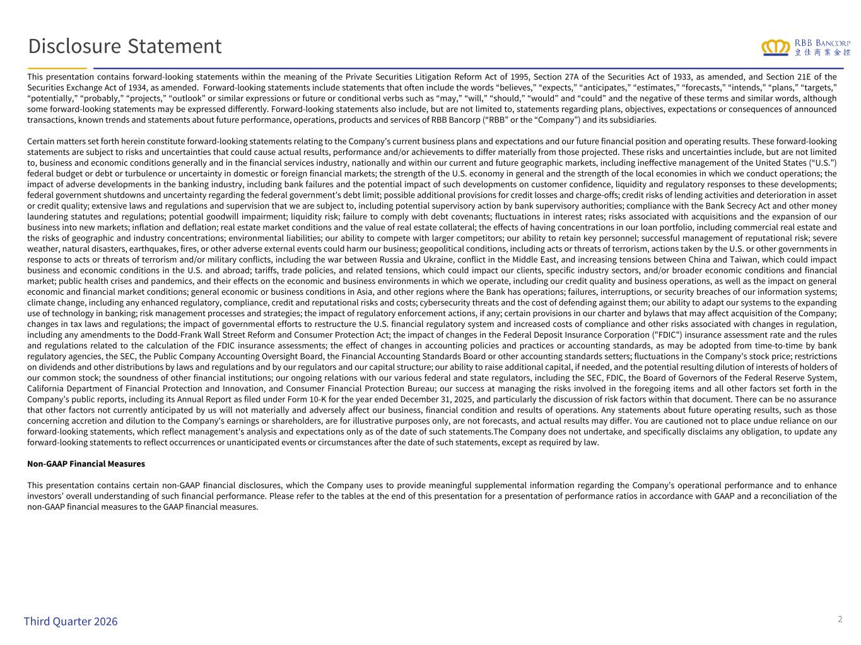
This presentation contains forward-looking statements within the meaning of the Private Securities Litigation Reform Act of 1995, Section 27A of the Securities Act of 1933, as amended, and Section 21E of the Securities Exchange Act of 1934, as amended. Forward-looking statements include statements that often include the words “believes,” “expects,” “anticipates,” “estimates,” “forecasts,” “intends,” “plans,” “targets,” “potentially,” “probably,” “projects,” “outlook” or similar expressions or future or conditional verbs such as “may,” “will,” “should,” “would” and “could” and the negative of these terms and similar words, although some forward-looking statements may be expressed differently. Forward-looking statements also include, but are not limited to, statements regarding plans, objectives, expectations or consequences of announced transactions, known trends and statements about future performance, operations, products and services of RBB Bancorp (“RBB” or the “Company”) and its subsidiaries. Certain matters set forth herein constitute forward-looking statements relating to the Company’s current business plans and expectations and our future financial position and operating results. These forward-looking statements are subject to risks and uncertainties that could cause actual results, performance and/or achievements to differ materially from those projected. These risks and uncertainties include, but are not limited to, business and economic conditions generally and in the financial services industry, nationally and within our current and future geographic markets, including ineffective management of the United States (“U.S.”) federal budget or debt or turbulence or uncertainty in domestic or foreign financial markets; the strength of the U.S. economy in general and the strength of the local economies in which we conduct operations; the impact of adverse developments in the banking industry, including bank failures and the potential impact of such developments on customer confidence, liquidity and regulatory responses to these developments; federal government shutdowns and uncertainty regarding the federal government’s debt limit; possible additional provisions for credit losses and charge-offs; credit risks of lending activities and deterioration in asset or credit quality; extensive laws and regulations and supervision that we are subject to, including potential supervisory action by bank supervisory authorities; compliance with the Bank Secrecy Act and other money laundering statutes and regulations; potential goodwill impairment; liquidity risk; failure to comply with debt covenants; fluctuations in interest rates; risks associated with acquisitions and the expansion of our business into new markets; inflation and deflation; real estate market conditions and the value of real estate collateral; the effects of having concentrations in our loan portfolio, including commercial real estate and the risks of geographic and industry concentrations; environmental liabilities; our ability to compete with larger competitors; our ability to retain key personnel; successful management of reputational risk; severe weather, natural disasters, earthquakes, fires, or other adverse external events could harm our business; geopolitical conditions, including acts or threats of terrorism, actions taken by the U.S. or other governments in response to acts or threats of terrorism and/or military conflicts, including the war between Russia and Ukraine, conflict in the Middle East, and increasing tensions between China and Taiwan, which could impact business and economic conditions in the U.S. and abroad; tariffs, trade policies, and related tensions, which could impact our clients, specific industry sectors, and/or broader economic conditions and financial market; public health crises and pandemics, and their effects on the economic and business environments in which we operate, including our credit quality and business operations, as well as the impact on general economic and financial market conditions; general economic or business conditions in Asia, and other regions where the Bank has operations; failures, interruptions, or security breaches of our information systems; climate change, including any enhanced regulatory, compliance, credit and reputational risks and costs; cybersecurity threats and the cost of defending against them; our ability to adapt our systems to the expanding use of technology in banking; risk management processes and strategies; the impact of regulatory enforcement actions, if any; certain provisions in our charter and bylaws that may affect acquisition of the Company; changes in tax laws and regulations; the impact of governmental efforts to restructure the U.S. financial regulatory system and increased costs of compliance and other risks associated with changes in regulation, including any amendments to the Dodd-Frank Wall Street Reform and Consumer Protection Act; the impact of changes in the Federal Deposit Insurance Corporation ("FDIC") insurance assessment rate and the rules and regulations related to the calculation of the FDIC insurance assessments; the effect of changes in accounting policies and practices or accounting standards, as may be adopted from time-to-time by bank regulatory agencies, the SEC, the Public Company Accounting Oversight Board, the Financial Accounting Standards Board or other accounting standards setters; fluctuations in the Company’s stock price; restrictions on dividends and other distributions by laws and regulations and by our regulators and our capital structure; our ability to raise additional capital, if needed, and the potential resulting dilution of interests of holders of our common stock; the soundness of other financial institutions; our ongoing relations with our various federal and state regulators, including the SEC, FDIC, the Board of Governors of the Federal Reserve System, California Department of Financial Protection and Innovation, and Consumer Financial Protection Bureau; our success at managing the risks involved in the foregoing items and all other factors set forth in the Company’s public reports, including its Annual Report as filed under Form 10-K for the year ended December 31, 2025, and particularly the discussion of risk factors within that document. There can be no assurance that other factors not currently anticipated by us will not materially and adversely affect our business, financial condition and results of operations. Any statements about future operating results, such as those concerning accretion and dilution to the Company's earnings or shareholders, are for illustrative purposes only, are not forecasts, and actual results may differ. You are cautioned not to place undue reliance on our forward-looking statements, which reflect management's analysis and expectations only as of the date of such statements.The Company does not undertake, and specifically disclaims any obligation, to update any forward-looking statements to reflect occurrences or unanticipated events or circumstances after the date of such statements, except as required by law. Non-GAAP Financial Measures This presentation contains certain non-GAAP financial disclosures, which the Company uses to provide meaningful supplemental information regarding the Company’s operational performance and to enhance investors’ overall understanding of such financial performance. Please refer to the tables at the end of this presentation for a presentation of performance ratios in accordance with GAAP and a reconciliation of the non-GAAP financial measures to the GAAP financial measures. 2Third Quarter 2026 Disclosure Statement

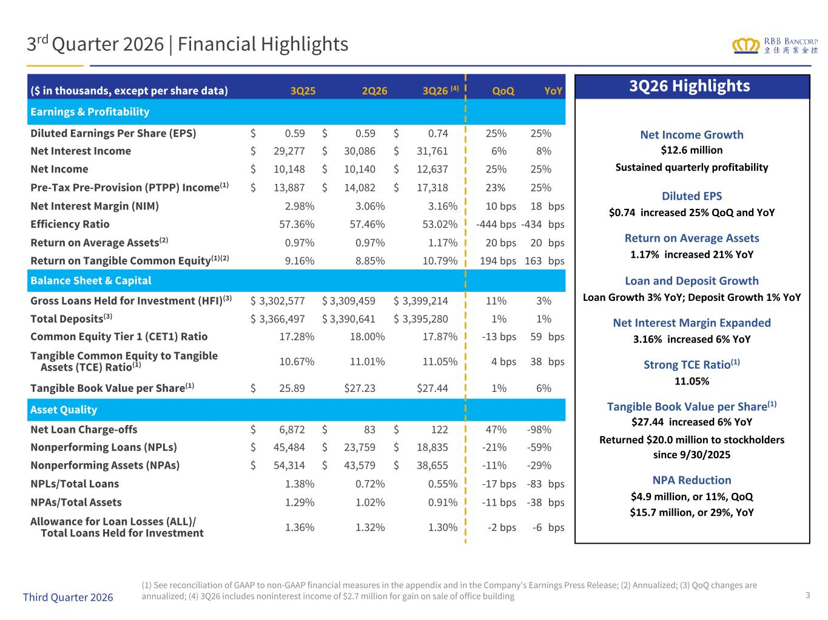
($ in thousands, except per share data) 3Q25 2Q26 3Q26 (4) QoQ YoY Earnings & Profitability Diluted Earnings Per Share (EPS) $ 0.59 $ 0.59 $ 0.74 25% 25% Net Interest Income $ 29,277 $ 30,086 $ 31,761 6% 8% Net Income $ 10,148 $ 10,140 $ 12,637 25% 25% Pre-Tax Pre-Provision (PTPP) Income(1) $ 13,887 $ 14,082 $ 17,318 23% 25% Net Interest Margin (NIM) 2.98% 3.06% 3.16% 10 bps 18 bps Efficiency Ratio 57.36% 57.46% 53.02% -444 bps -434 bps Return on Average Assets(2) 0.97% 0.97% 1.17% 20 bps 20 bps Return on Tangible Common Equity(1)(2) 9.16% 8.85% 10.79% 194 bps 163 bps Balance Sheet & Capital Gross Loans Held for Investment (HFI)(3) $ 3,302,577 $ 3,309,459 $ 3,399,214 11% 3% Total Deposits(3) $ 3,366,497 $ 3,390,641 $ 3,395,280 1% 1% Common Equity Tier 1 (CET1) Ratio 17.28% 18.00% 17.87% -13 bps 59 bps Tangible Common Equity to Tangible Assets (TCE) Ratio(1) 10.67% 11.01% 11.05% 4 bps 38 bps Tangible Book Value per Share(1) $ 25.89 $27.23 $27.44 1% 6% Asset Quality Net Loan Charge-offs $ 6,872 $ 83 $ 122 47% -98% Nonperforming Loans (NPLs) $ 45,484 $ 23,759 $ 18,835 -21% -59% Nonperforming Assets (NPAs) $ 54,314 $ 43,579 $ 38,655 -11% -29% NPLs/Total Loans 1.38% 0.72% 0.55% -17 bps -83 bps NPAs/Total Assets 1.29% 1.02% 0.91% -11 bps -38 bps Allowance for Loan Losses (ALL)/ Total Loans Held for Investment 1.36% 1.32% 1.30% -2 bps -6 bps 3rd Quarter 2026 | Financial Highlights 3Q26 Highlights 3 (1) See reconciliation of GAAP to non-GAAP financial measures in the appendix and in the Company’s Earnings Press Release; (2) Annualized; (3) QoQ changes are annualized; (4) 3Q26 includes noninterest income of $2.7 million for gain on sale of office buildingThird Quarter 2026 Net Income Growth $12.6 million Sustained quarterly profitability Diluted EPS $0.74 increased 25% QoQ and YoY Return on Average Assets 1.17% increased 21% YoY Loan and Deposit Growth Loan Growth 3% YoY; Deposit Growth 1% YoY Net Interest Margin Expanded 3.16% increased 6% YoY Strong TCE Ratio(1) 11.05% Tangible Book Value per Share(1) $27.44 increased 6% YoY Returned $20.0 million to stockholders since 9/30/2025 NPA Reduction $4.9 million, or 11%, QoQ $15.7 million, or 29%, YoY

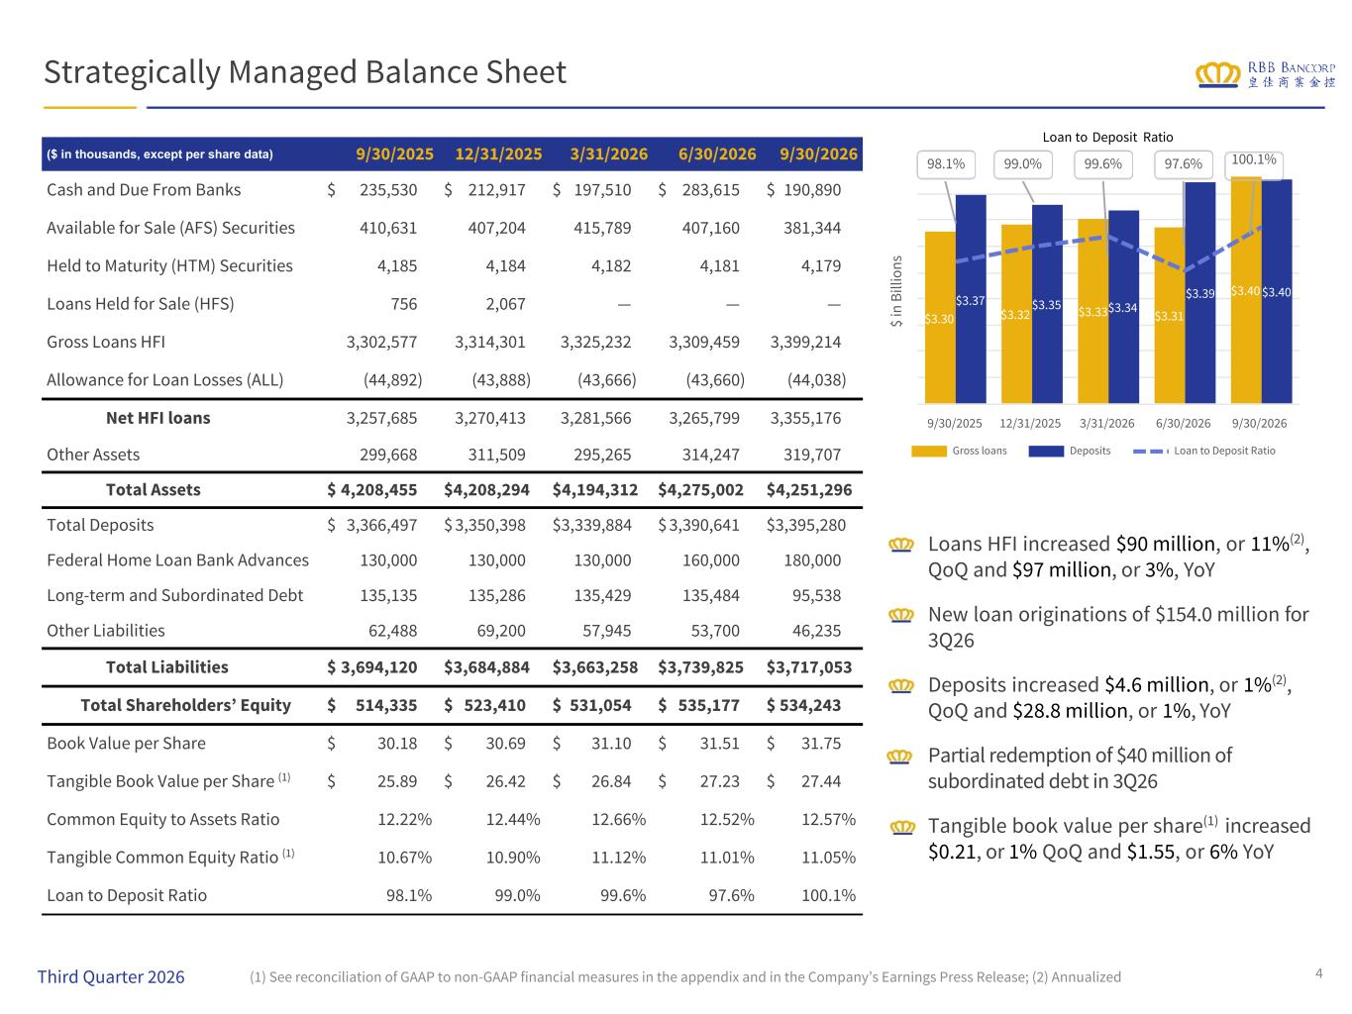
Strategically Managed Balance Sheet Loans HFI increased $90 million, or 11%(2), QoQ and $97 million, or 3%, YoY New loan originations of $154.0 million for 3Q26 Deposits increased $4.6 million, or 1%(2), QoQ and $28.8 million, or 1%, YoY Partial redemption of $40 million of subordinated debt in 3Q26 Tangible book value per share(1) increased $0.21, or 1% QoQ and $1.55, or 6% YoY ($ in thousands, except per share data) 9/30/2025 12/31/2025 3/31/2026 6/30/2026 9/30/2026 Cash and Due From Banks $ 235,530 $ 212,917 $ 197,510 $ 283,615 $ 190,890 Available for Sale (AFS) Securities 410,631 407,204 415,789 407,160 381,344 Held to Maturity (HTM) Securities 4,185 4,184 4,182 4,181 4,179 Loans Held for Sale (HFS) 756 2,067 — — — Gross Loans HFI 3,302,577 3,314,301 3,325,232 3,309,459 3,399,214 Allowance for Loan Losses (ALL) (44,892) (43,888) (43,666) (43,660) (44,038) Net HFI loans 3,257,685 3,270,413 3,281,566 3,265,799 3,355,176 Other Assets 299,668 311,509 295,265 314,247 319,707 Total Assets $ 4,208,455 $ 4,208,294 $ 4,194,312 $ 4,275,002 $ 4,251,296 Total Deposits $ 3,366,497 $ 3,350,398 $ 3,339,884 $ 3,390,641 $ 3,395,280 Federal Home Loan Bank Advances 130,000 130,000 130,000 160,000 180,000 Long-term and Subordinated Debt 135,135 135,286 135,429 135,484 95,538 Other Liabilities 62,488 69,200 57,945 53,700 46,235 Total Liabilities $ 3,694,120 $ 3,684,884 $ 3,663,258 $ 3,739,825 $ 3,717,053 Total Shareholders’ Equity $ 514,335 $ 523,410 $ 531,054 $ 535,177 $ 534,243 Book Value per Share $ 30.18 $ 30.69 $ 31.10 $ 31.51 $ 31.75 Tangible Book Value per Share (1) $ 25.89 $ 26.42 $ 26.84 $ 27.23 $ 27.44 Common Equity to Assets Ratio 12.22% 12.44% 12.66% 12.52% 12.57% Tangible Common Equity Ratio (1) 10.67% 10.90% 11.12% 11.01% 11.05% Loan to Deposit Ratio 98.1% 99.0% 99.6% 97.6% 100.1% Loan to Deposit Ratio 4(1) See reconciliation of GAAP to non-GAAP financial measures in the appendix and in the Company’s Earnings Press Release; (2) Annualized $ in B ill io ns $3.30 $3.32 $3.33 $3.31 $3.40 $3.37 $3.35 $3.34 $3.39 $3.40 Gross loans Deposits Loan to Deposit Ratio 9/30/2025 12/31/2025 3/31/2026 6/30/2026 9/30/2026 98.1% 99.0% 99.6% 97.6% 100.1% Third Quarter 2026

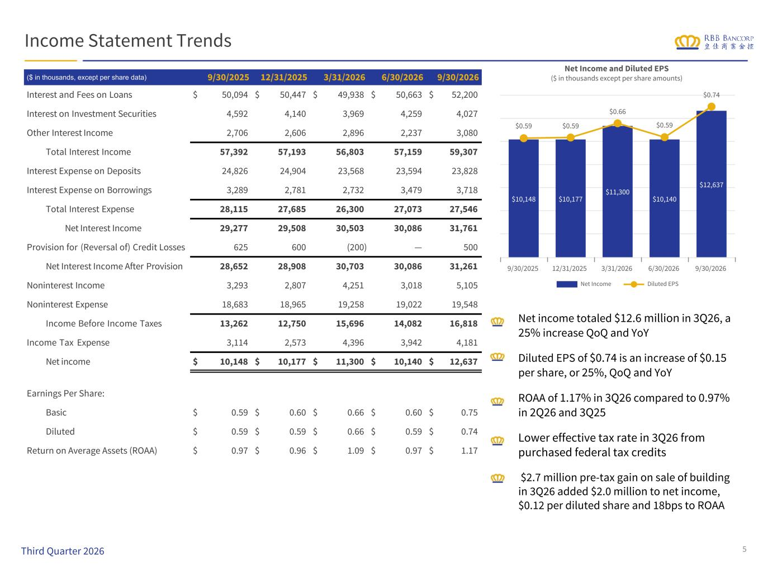
Income Statement Trends ($ in thousands, except per share data) 9/30/2025 12/31/2025 3/31/2026 6/30/2026 9/30/2026 Interest and Fees on Loans $ 50,094 $ 50,447 $ 49,938 $ 50,663 $ 52,200 Interest on Investment Securities 4,592 4,140 3,969 4,259 4,027 Other Interest Income 2,706 2,606 2,896 2,237 3,080 Total Interest Income 57,392 57,193 56,803 57,159 59,307 Interest Expense on Deposits 24,826 24,904 23,568 23,594 23,828 Interest Expense on Borrowings 3,289 2,781 2,732 3,479 3,718 Total Interest Expense 28,115 27,685 26,300 27,073 27,546 Net Interest Income 29,277 29,508 30,503 30,086 31,761 Provision for (Reversal of) Credit Losses 625 600 (200) — 500 Net Interest Income After Provision 28,652 28,908 30,703 30,086 31,261 Noninterest Income 3,293 2,807 4,251 3,018 5,105 Noninterest Expense 18,683 18,965 19,258 19,022 19,548 Income Before Income Taxes 13,262 12,750 15,696 14,082 16,818 Income Tax Expense 3,114 2,573 4,396 3,942 4,181 Net income $ 10,148 $ 10,177 $ 11,300 $ 10,140 $ 12,637 Earnings Per Share: Basic $ 0.59 $ 0.60 $ 0.66 $ 0.60 $ 0.75 Diluted $ 0.59 $ 0.59 $ 0.66 $ 0.59 $ 0.74 Return on Average Assets (ROAA) $ 0.97 $ 0.96 $ 1.09 $ 0.97 $ 1.17 Net income totaled $12.6 million in 3Q26, a 25% increase QoQ and YoY Diluted EPS of $0.74 is an increase of $0.15 per share, or 25%, QoQ and YoY ROAA of 1.17% in 3Q26 compared to 0.97% in 2Q26 and 3Q25 Lower effective tax rate in 3Q26 from purchased federal tax credits $2.7 million pre-tax gain on sale of building in 3Q26 added $2.0 million to net income, $0.12 per diluted share and 18bps to ROAA 5 Net Income and Diluted EPS ($ in thousands except per share amounts) $10,148 $10,177 $11,300 $10,140 $12,637 $0.59 $0.59 $0.66 $0.59 $0.74 Net Income Diluted EPS 9/30/2025 12/31/2025 3/31/2026 6/30/2026 9/30/2026 Third Quarter 2026

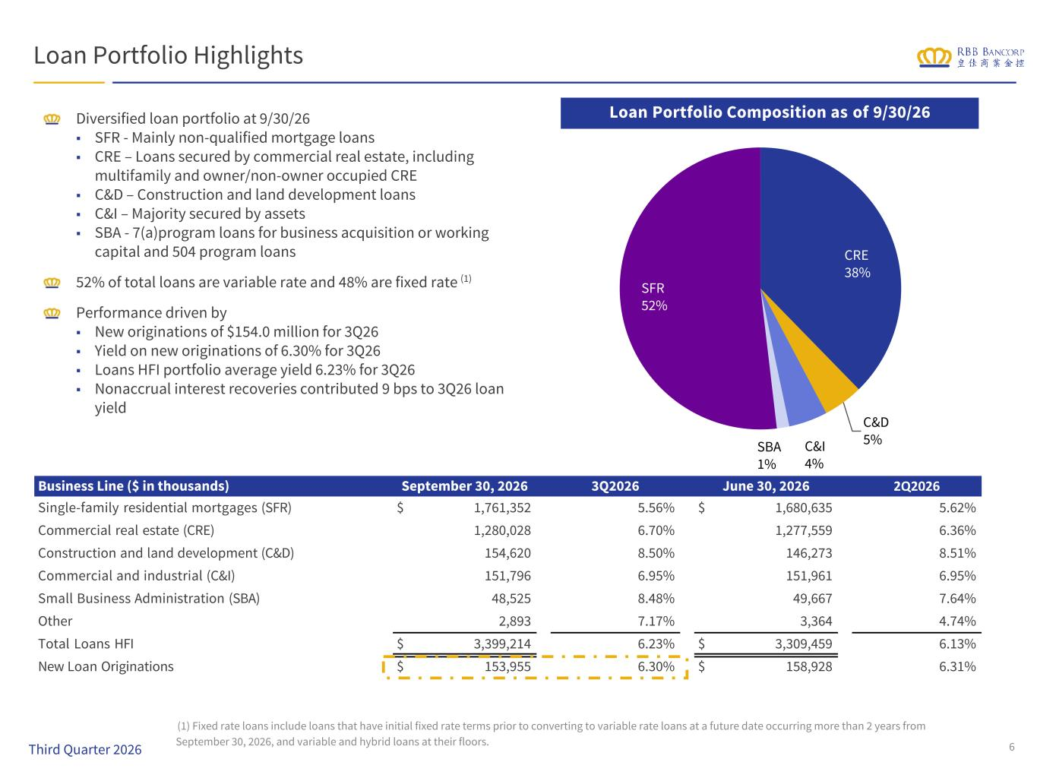
CRE 38% C&D 5%C&I 4% SBA 1% SFR 52% Business Line ($ in thousands) September 30, 2026 3Q2026 June 30, 2026 2Q2026 Single-family residential mortgages (SFR) $ 1,761,352 5.56% $ 1,680,635 5.62% Commercial real estate (CRE) 1,280,028 6.70% 1,277,559 6.36% Construction and land development (C&D) 154,620 8.50% 146,273 8.51% Commercial and industrial (C&I) 151,796 6.95% 151,961 6.95% Small Business Administration (SBA) 48,525 8.48% 49,667 7.64% Other 2,893 7.17% 3,364 4.74% Total Loans HFI $ 3,399,214 6.23% $ 3,309,459 6.13% New Loan Originations $ 153,955 6.30% $ 158,928 6.31% Loan Portfolio Highlights Diversified loan portfolio at 9/30/26 ■ SFR - Mainly non-qualified mortgage loans ■ CRE – Loans secured by commercial real estate, including multifamily and owner/non-owner occupied CRE ■ C&D – Construction and land development loans ■ C&I – Majority secured by assets ■ SBA - 7(a)program loans for business acquisition or working capital and 504 program loans 52% of total loans are variable rate and 48% are fixed rate (1) Performance driven by ■ New originations of $154.0 million for 3Q26 ■ Yield on new originations of 6.30% for 3Q26 ■ Loans HFI portfolio average yield 6.23% for 3Q26 ■ Nonaccrual interest recoveries contributed 9 bps to 3Q26 loan yield Loan Portfolio Composition as of 9/30/26 6 (1) Fixed rate loans include loans that have initial fixed rate terms prior to converting to variable rate loans at a future date occurring more than 2 years from September 30, 2026, and variable and hybrid loans at their floors. Third Quarter 2026

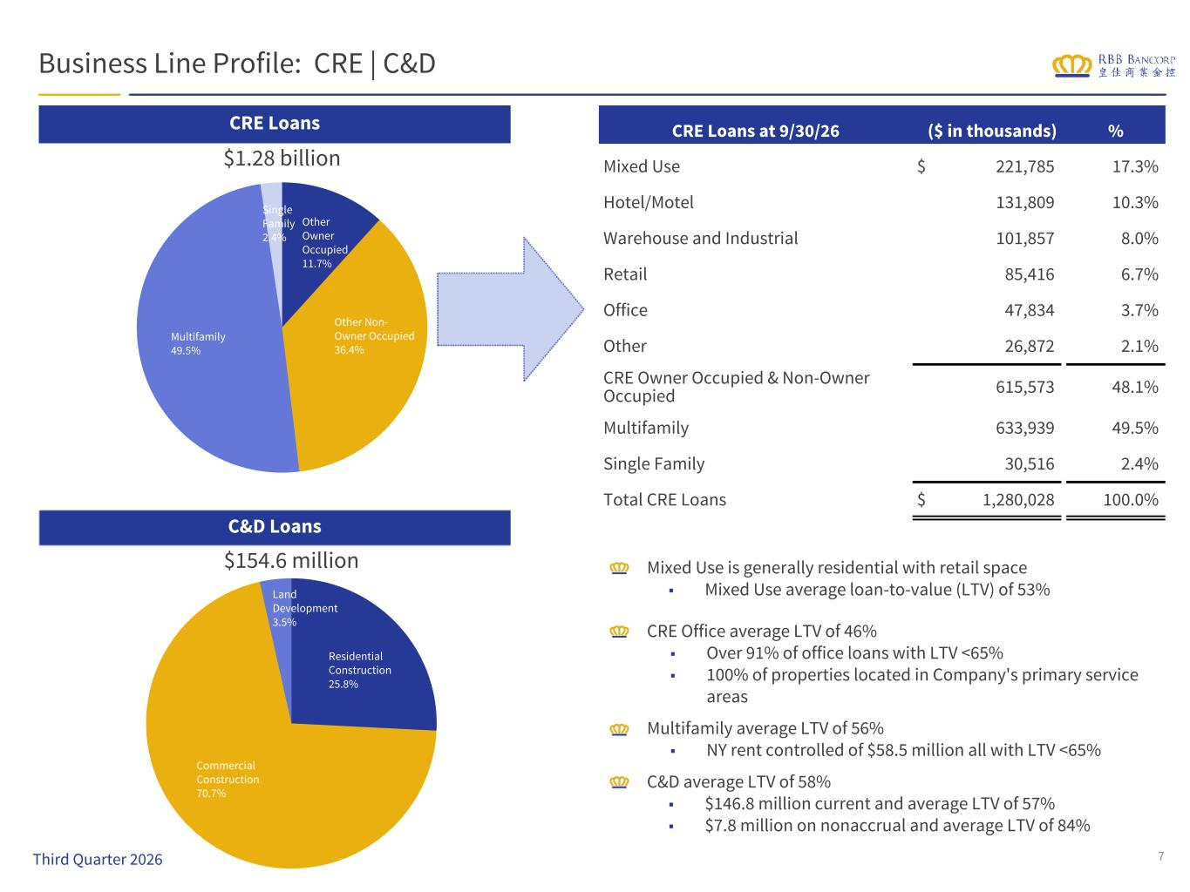
Residential Construction 25.8% Commercial Construction 70.7% Land Development 3.5% Other Owner Occupied 11.7% Other Non- Owner Occupied 36.4% Multifamily 49.5% Single Family 2.4% Business Line Profile: CRE | C&D CRE Loans C&D Loans $1.28 billion $154.6 million Mixed Use is generally residential with retail space ■ Mixed Use average loan-to-value (LTV) of 53% CRE Office average LTV of 46% ■ Over 91% of office loans with LTV <65% ■ 100% of properties located in Company's primary service areas Multifamily average LTV of 56% ■ NY rent controlled of $58.5 million all with LTV <65% C&D average LTV of 58% ■ $146.8 million current and average LTV of 57% ■ $7.8 million on nonaccrual and average LTV of 84% CRE Loans at 9/30/26 ($ in thousands) % Mixed Use $ 221,785 17.3% Hotel/Motel 131,809 10.3% Warehouse and Industrial 101,857 8.0% Retail 85,416 6.7% Office 47,834 3.7% Other 26,872 2.1% CRE Owner Occupied & Non-Owner Occupied 615,573 48.1% Multifamily 633,939 49.5% Single Family 30,516 2.4% Total CRE Loans $ 1,280,028 100.0% 7Third Quarter 2026

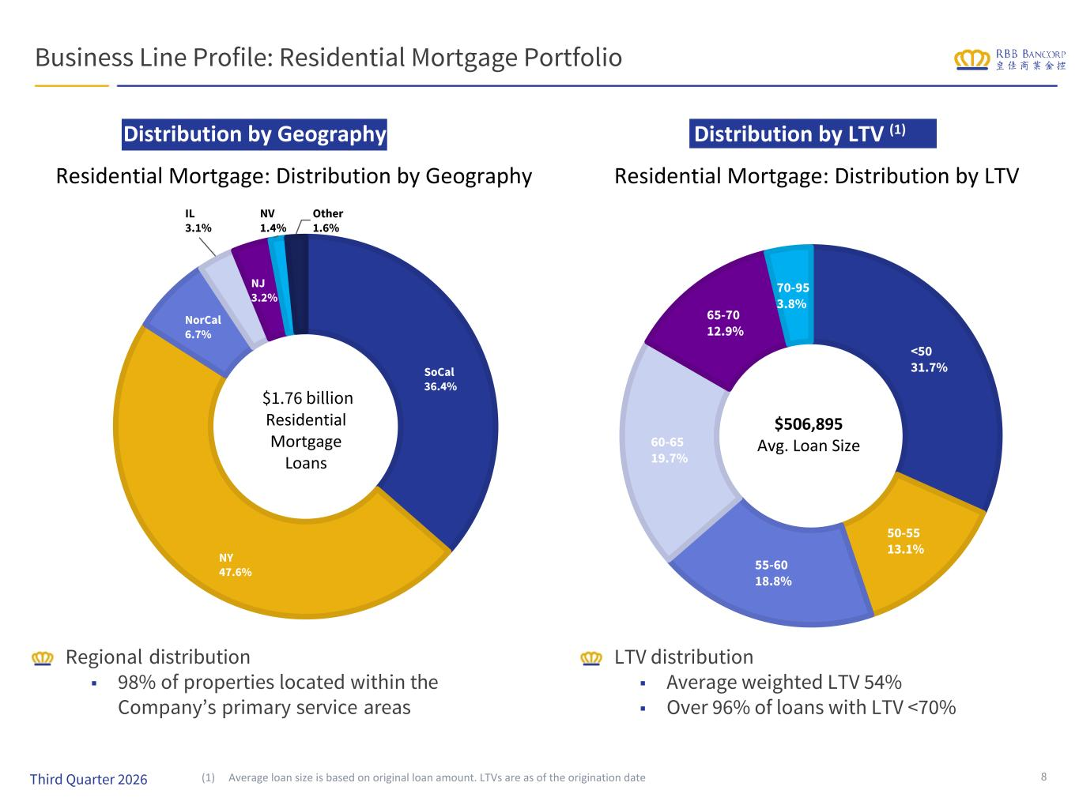
Distribution by LTV (1) Business Line Profile: Residential Mortgage Portfolio Distribution by Geography Regional distribution ■ 98% of properties located within the Company’s primary service areas LTV distribution ■ Average weighted LTV 54% ■ Over 96% of loans with LTV <70% (1) Average loan size is based on original loan amount. LTVs are as of the origination date 8 SoCal 36.4% NY 47.6% NorCal 6.7% IL 3.1% NJ 3.2% NV 1.4% Other 1.6% <50 31.7% 50-55 13.1% 55-60 18.8% 60-65 19.7% 65-70 12.9% 70-95 3.8% $1.76 billion Residential Mortgage Loans $506,895 Avg. Loan Size Third Quarter 2026 Residential Mortgage: Distribution by Geography Residential Mortgage: Distribution by LTV

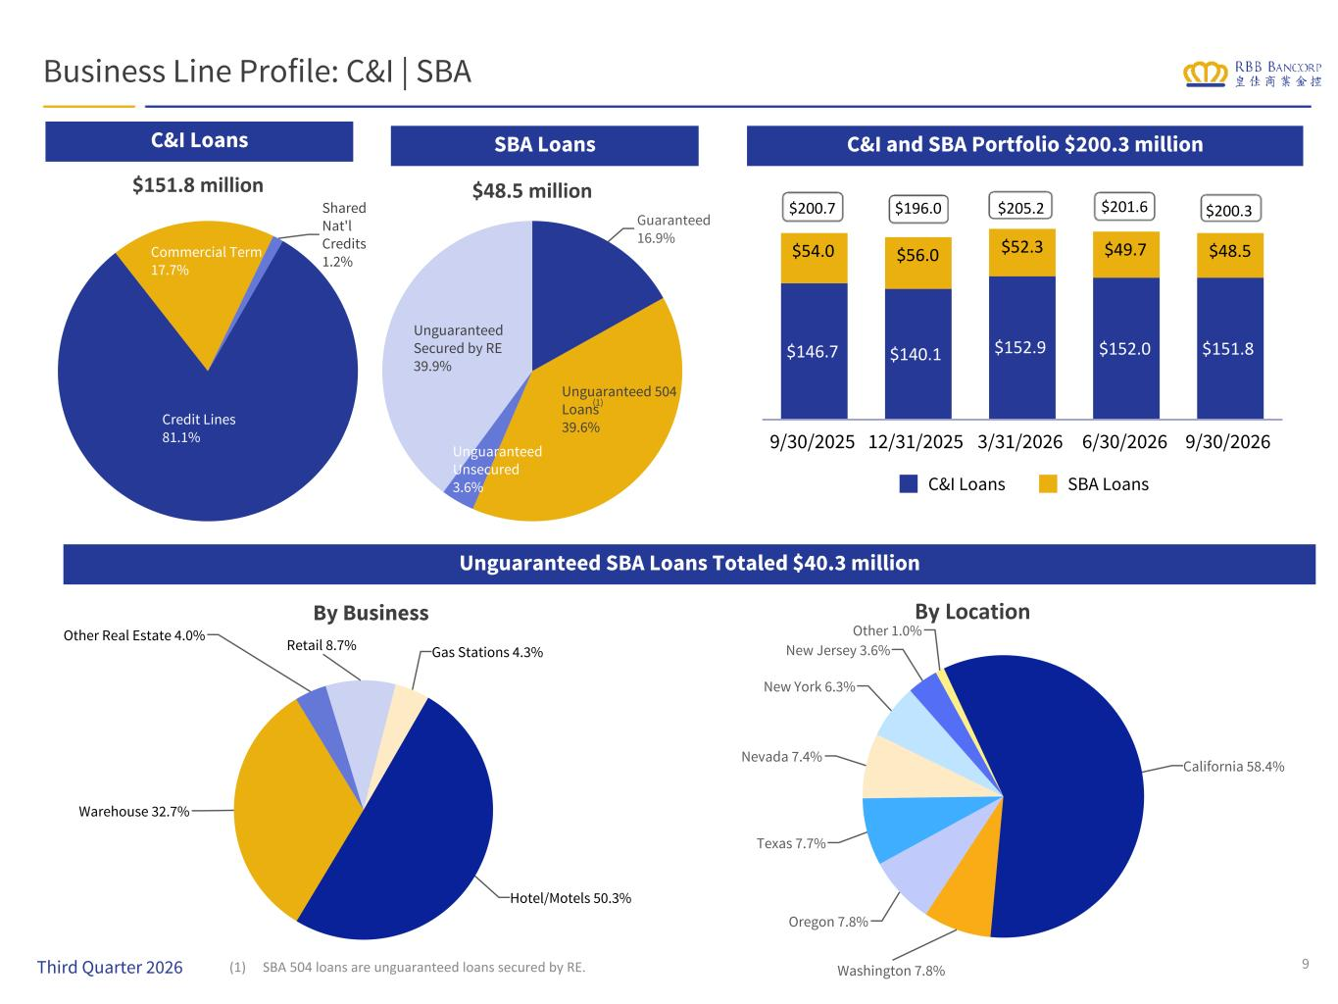
Guaranteed 16.9% Unguaranteed 504 Loans 39.6% Unguaranteed Unsecured 3.6% Unguaranteed Secured by RE 39.9% Credit Lines 81.1% Commercial Term 17.7% Shared Nat'l Credits 1.2% $146.7 $140.1 $152.9 $152.0 $151.8 $54.0 $56.0 $52.3 $49.7 $48.5 C&I Loans SBA Loans 9/30/2025 12/31/2025 3/31/2026 6/30/2026 9/30/2026 Business Line Profile: C&I | SBA $151.8 million $48.5 million C&I and SBA Portfolio $200.3 million By LocationBy Business Unguaranteed SBA Loans Totaled $40.3 million C&I Loans SBA Loans (1) SBA 504 loans are unguaranteed loans secured by RE. 9 California 66.8% (1) Third Quarter 2026 $200.7 $196.0 $205.2 $201.6 $200.3 California 58.4% Washington 7.8% Oregon 7.8% Texas 7.7% Nevada 7.4% New York 6.3% New Jersey 3.6% Other 1.0% Hotel/Motels 50.3% Warehouse 32.7% Other Real Estate 4.0% Retail 8.7% Gas Stations 4.3%

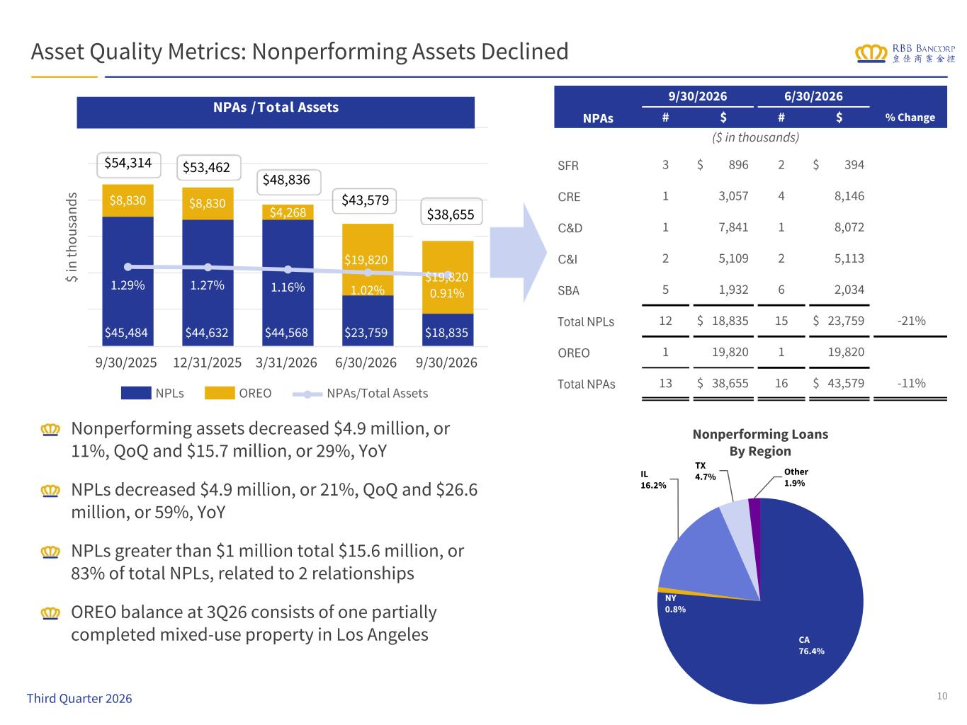
$ in th ou sa nd s $45,484 $44,632 $44,568 $23,759 $18,835 $8,830 $8,830 $4,268 $19,820 $19,8201.29% 1.27% 1.16% 1.02% 0.91% NPLs OREO NPAs/Total Assets 9/30/2025 12/31/2025 3/31/2026 6/30/2026 9/30/2026 $54,314 $48,836 $43,579 $38,655 NPAs / Total Assets Asset Quality Metrics: Nonperforming Assets Declined Nonperforming assets decreased $4.9 million, or 11%, QoQ and $15.7 million, or 29%, YoY NPLs decreased $4.9 million, or 21%, QoQ and $26.6 million, or 59%, YoY NPLs greater than $1 million total $15.6 million, or 83% of total NPLs, related to 2 relationships OREO balance at 3Q26 consists of one partially completed mixed-use property in Los Angeles 10 Nonperforming Loans By Region $53,462 NPAs 9/30/2026 6/30/2026 # $ # $ % Change ($ in thousands) SFR 3 $ 896 2 $ 394 CRE 1 3,057 4 8,146 C&D 1 7,841 1 8,072 C&I 2 5,109 2 5,113 SBA 5 1,932 6 2,034 Total NPLs 12 $ 18,835 15 $ 23,759 -21% OREO 1 19,820 1 19,820 Total NPAs 13 $ 38,655 16 $ 43,579 -11% CA 76.4% NY 0.8% IL 16.2% TX 4.7% Other 1.9% Third Quarter 2026

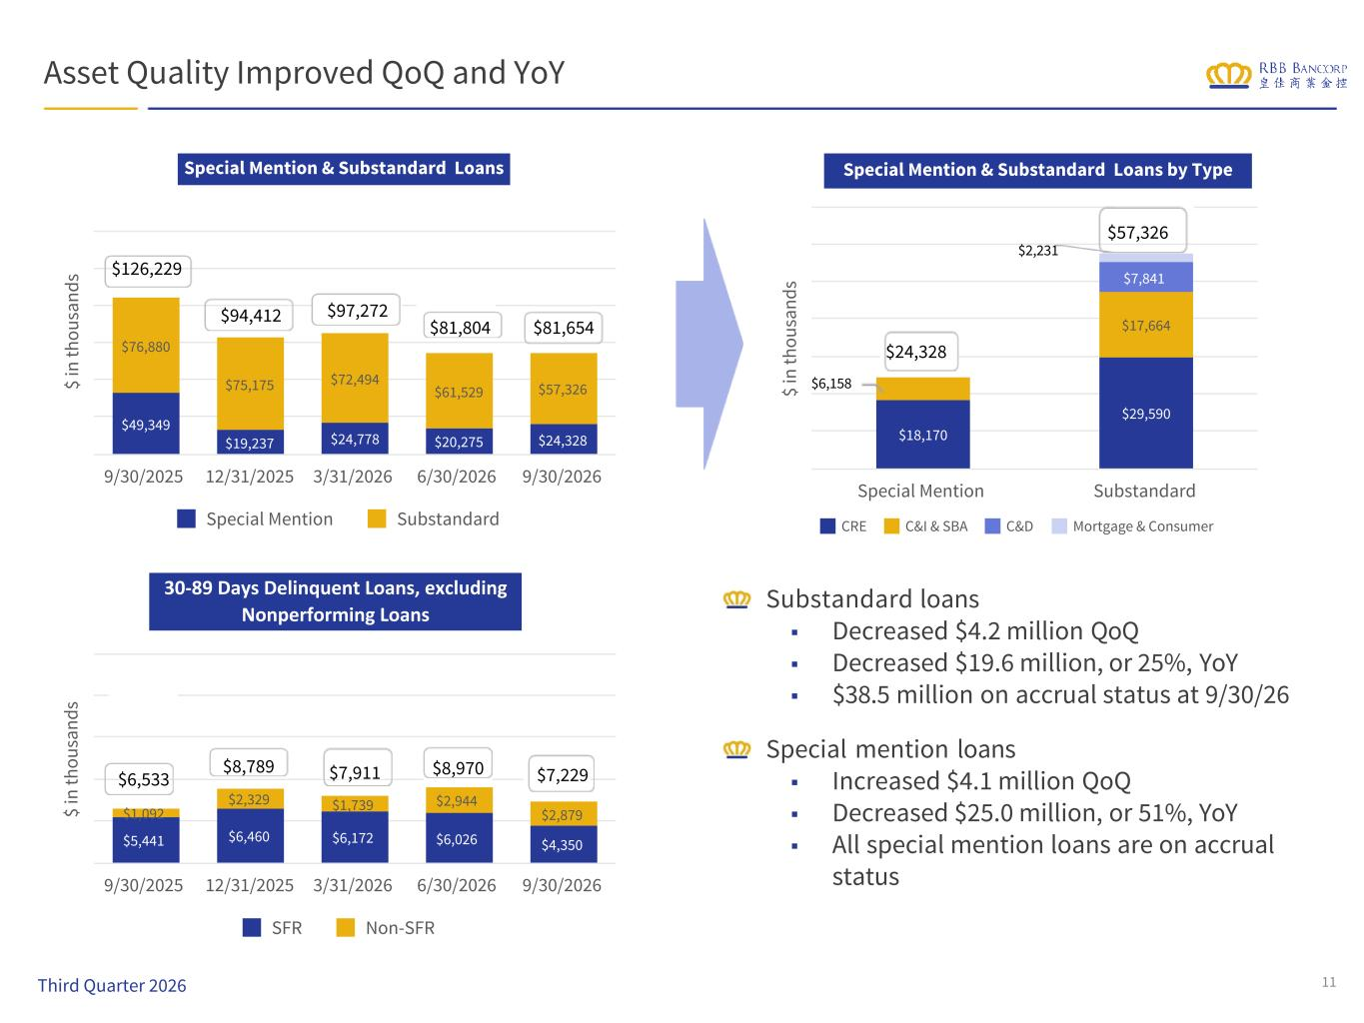
$ in th ou sa nd s $18,170 $29,590 $17,664 $7,841 CRE C&I & SBA C&D Mortgage & Consumer Special Mention Substandard $ in th ou sa nd s $5,441 $6,460 $6,172 $6,026 $4,350 $1,092 $2,329 $1,739 $2,944 $2,879 SFR Non-SFR 9/30/2025 12/31/2025 3/31/2026 6/30/2026 9/30/2026 $ in th ou sa nd s $49,349 $19,237 $24,778 $20,275 $24,328 $76,880 $75,175 $72,494 $61,529 $57,326 Special Mention Substandard 9/30/2025 12/31/2025 3/31/2026 6/30/2026 9/30/2026 $6,158 $2,231 $24,328 Special Mention & Substandard Loans by Type $8,789 $7,911 $8,970 $7,229 30-89 Days Delinquent Loans, excluding Nonperforming Loans $94,412 $97,272 $81,804 Special Mention & Substandard Loans Asset Quality Improved QoQ and YoY Substandard loans ■ Decreased $4.2 million QoQ ■ Decreased $19.6 million, or 25%, YoY ■ $38.5 million on accrual status at 9/30/26 Special mention loans ■ Increased $4.1 million QoQ ■ Decreased $25.0 million, or 51%, YoY ■ All special mention loans are on accrual status 11 $126,229 $57,326 Third Quarter 2026 $81,654 $6,533

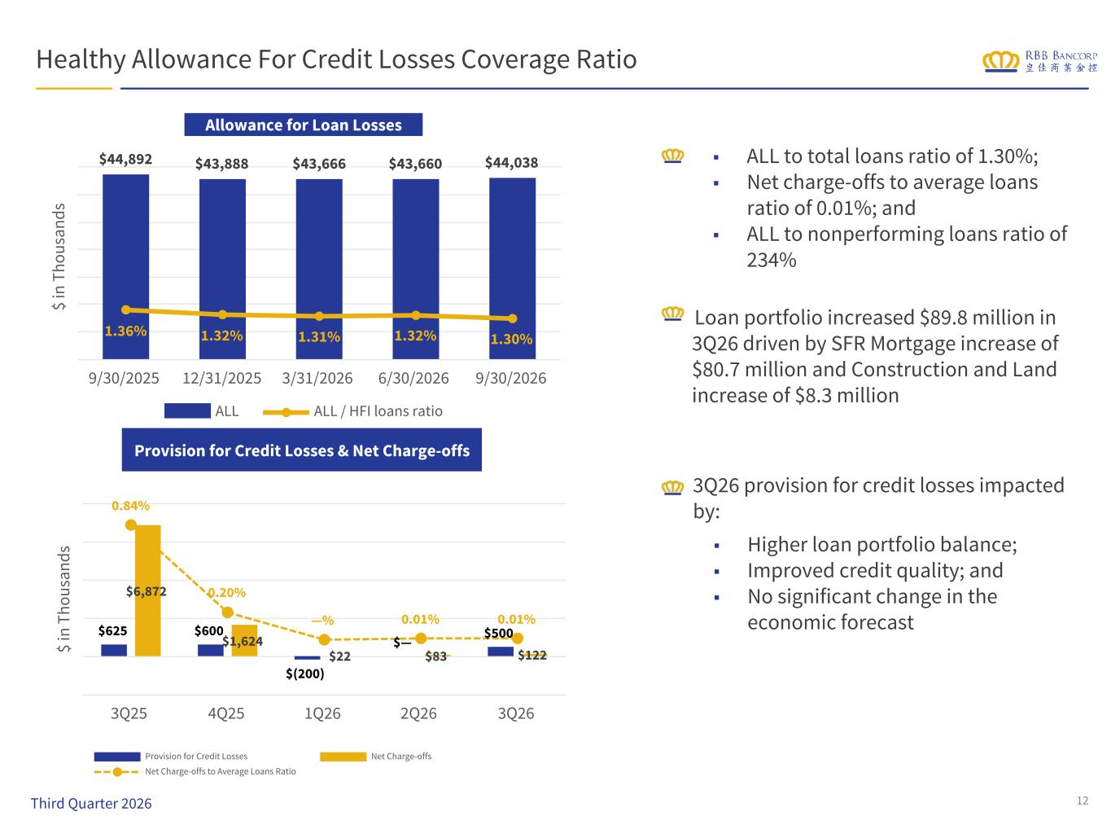
Provision for Credit Losses & Net Charge-offs Healthy Allowance For Credit Losses Coverage Ratio Loan portfolio increased $89.8 million in 3Q26 driven by SFR Mortgage increase of $80.7 million and Construction and Land increase of $8.3 million Allowance for Loan Losses (ALL) 12 $ in T ho us an ds $44,892 $43,888 $43,666 $43,660 $44,038 1.36% 1.32% 1.31% 1.32% 1.30% ALL ALL / HFI loans ratio 9/30/2025 12/31/2025 3/31/2026 6/30/2026 9/30/2026 $ in T ho us an ds $625 $600 $(200) $— $500 $6,872 $1,624 $22 $83 $122 0.84% 0.20% —% 0.01% 0.01% Provision for Credit Losses Net Charge-offs Net Charge-offs to Average Loans Ratio 3Q25 4Q25 1Q26 2Q26 3Q26 Third Quarter 2026 ■ Higher loan portfolio balance; ■ Improved credit quality; and ■ No significant change in the economic forecast 3Q26 provision for credit losses impacted by: ■ ALL to total loans ratio of 1.30%; ■ Net charge-offs to average loans ratio of 0.01%; and ■ ALL to nonperforming loans ratio of 234%

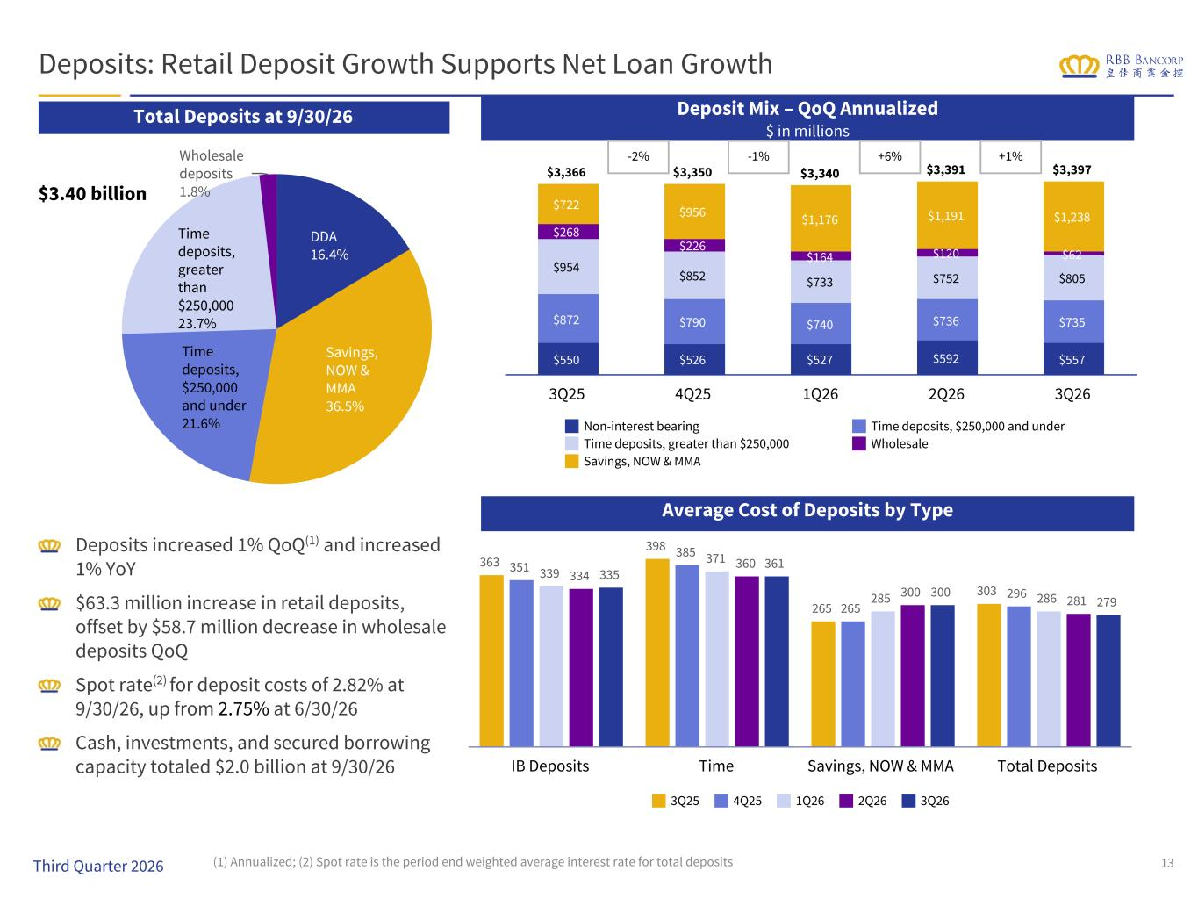
363 398 265 303 351 385 265 296 339 371 285 286 334 360 300 281 335 361 300 279 3Q25 4Q25 1Q26 2Q26 3Q26 IB Deposits Time Savings, NOW & MMA Total Deposits DDA 16.4% Savings, NOW & MMA 36.5% Time deposits, $250,000 and under 21.6% Time deposits, greater than $250,000 23.7% Wholesale deposits 1.8% Deposits: Retail Deposit Growth Supports Net Loan Growth Total Deposits at 9/30/26 $3.40 billion Deposit Mix – QoQ Annualized $ in millions Deposits increased 1% QoQ(1) and increased 1% YoY $63.3 million increase in retail deposits, offset by $58.7 million decrease in wholesale deposits QoQ Spot rate(2) for deposit costs of 2.82% at 9/30/26, up from 2.75% at 6/30/26 Cash, investments, and secured borrowing capacity totaled $2.0 billion at 9/30/26 (1) Annualized; (2) Spot rate is the period end weighted average interest rate for total deposits 13 $3,366 $3,350 $3,340 $3,391 $3,397 $550 $526 $527 $592 $557 $872 $790 $740 $736 $735 $954 $852 $733 $752 $805 $268 $226 $164 $120 $62 $722 $956 $1,176 $1,191 $1,238 Non-interest bearing Time deposits, $250,000 and under Time deposits, greater than $250,000 Wholesale Savings, NOW & MMA 3Q25 4Q25 1Q26 2Q26 3Q26 -2% -1% +6% +1% Third Quarter 2026 Average Cost of Deposits by Type

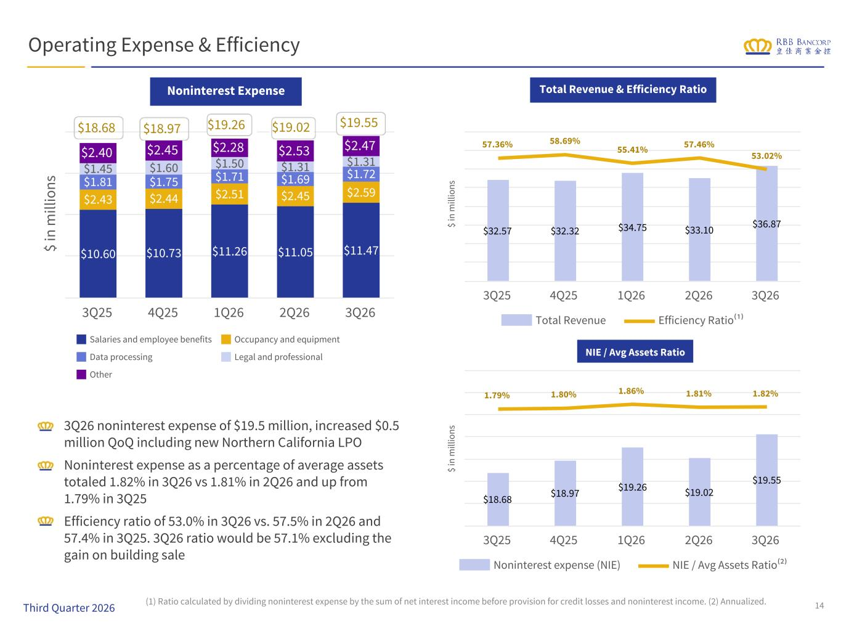
$ in m ill io ns $10.60 $10.73 $11.26 $11.05 $11.47 $2.43 $2.44 $2.51 $2.45 $2.59 $1.81 $1.75 $1.71 $1.69 $1.72$1.45 $1.60 $1.50 $1.31 $1.31 $2.40 $2.45 $2.28 $2.53 $2.47 Salaries and employee benefits Occupancy and equipment Data processing Legal and professional Other 3Q25 4Q25 1Q26 2Q26 3Q26 14 Operating Expense & Efficiency 3Q26 noninterest expense of $19.5 million, increased $0.5 million QoQ including new Northern California LPO Noninterest expense as a percentage of average assets totaled 1.82% in 3Q26 vs 1.81% in 2Q26 and up from 1.79% in 3Q25 Efficiency ratio of 53.0% in 3Q26 vs. 57.5% in 2Q26 and 57.4% in 3Q25. 3Q26 ratio would be 57.1% excluding the gain on building sale (1) Ratio calculated by dividing noninterest expense by the sum of net interest income before provision for credit losses and noninterest income. (2) Annualized. $18.68 $19.26 $19.02 $19.55 Noninterest Expense Total Revenue & Efficiency Ratio NIE / Avg Assets Ratio $18.97 $ in m ill io ns $32.57 $32.32 $34.75 $33.10 $36.87 57.36% 58.69% 55.41% 57.46% 53.02% Total Revenue Efficiency Ratio⁽¹⁾ 3Q25 4Q25 1Q26 2Q26 3Q26 $ in m ill io ns $18.68 $18.97 $19.26 $19.02 $19.55 1.79% 1.80% 1.86% 1.81% 1.82% Noninterest expense (NIE) NIE / Avg Assets Ratio⁽²⁾ 3Q25 4Q25 1Q26 2Q26 3Q26 Third Quarter 2026

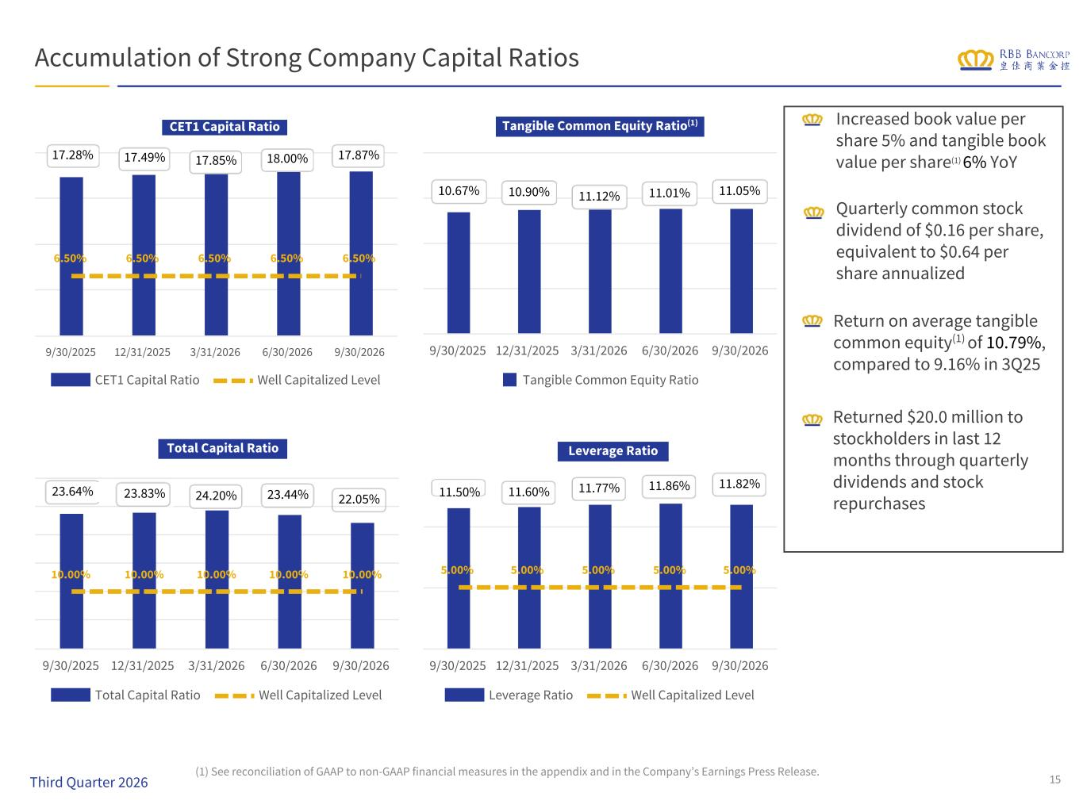
5.00% 5.00% 5.00% 5.00% 5.00% Leverage Ratio Well Capitalized Level 9/30/2025 12/31/2025 3/31/2026 6/30/2026 9/30/2026 10.00% 10.00% 10.00% 10.00% 10.00% Total Capital Ratio Well Capitalized Level 9/30/2025 12/31/2025 3/31/2026 6/30/2026 9/30/2026 Tangible Common Equity Ratio 9/30/2025 12/31/2025 3/31/2026 6/30/2026 9/30/2026 6.50% 6.50% 6.50% 6.50% 6.50% CET1 Capital Ratio Well Capitalized Level 9/30/2025 12/31/2025 3/31/2026 6/30/2026 9/30/2026 Accumulation of Strong Company Capital Ratios Increased book value per share 5% and tangible book value per share(1) 6% YoY Quarterly common stock dividend of $0.16 per share, equivalent to $0.64 per share annualized Return on average tangible common equity(1) of 10.79%, compared to 9.16% in 3Q25 Returned $20.0 million to stockholders in last 12 months through quarterly dividends and stock repurchases 17.28% 17.49% 17.85% 18.00% 17.87% CET1 Capital Ratio 23.64% 23.83% 24.20% 23.44% 22.05% Total Capital Ratio 10.67% 10.90% 11.12% 11.01% 11.05% Tangible Common Equity Ratio(1) 11.50% 11.60% 11.77% 11.86% 11.82% Leverage Ratio (1) See reconciliation of GAAP to non-GAAP financial measures in the appendix and in the Company’s Earnings Press Release. 15Third Quarter 2026


Appendix: Non-GAAP Reconciliations 16

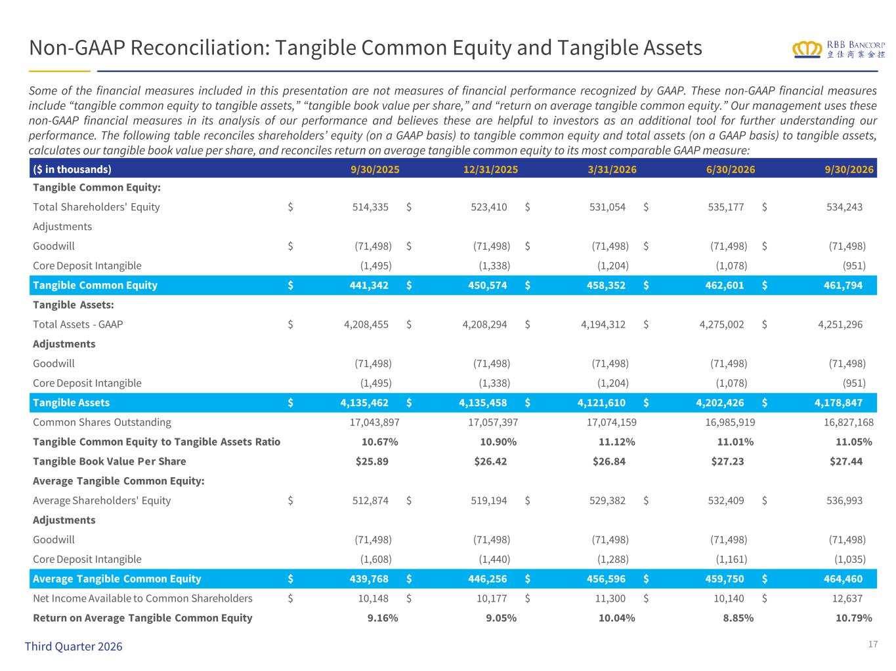
Non-GAAP Reconciliation: Tangible Common Equity and Tangible Assets Some of the financial measures included in this presentation are not measures of financial performance recognized by GAAP. These non-GAAP financial measures include “tangible common equity to tangible assets,” “tangible book value per share,” and “return on average tangible common equity.” Our management uses these non-GAAP financial measures in its analysis of our performance and believes these are helpful to investors as an additional tool for further understanding our performance. The following table reconciles shareholders’ equity (on a GAAP basis) to tangible common equity and total assets (on a GAAP basis) to tangible assets, calculates our tangible book value per share, and reconciles return on average tangible common equity to its most comparable GAAP measure: 17 ($ in thousands) 9/30/2025 12/31/2025 3/31/2026 6/30/2026 9/30/2026 Tangible Common Equity: Total Shareholders' Equity $ 514,335 $ 523,410 $ 531,054 $ 535,177 $ 534,243 Adjustments Goodwill $ (71,498) $ (71,498) $ (71,498) $ (71,498) $ (71,498) Core Deposit Intangible (1,495) (1,338) (1,204) (1,078) (951) Tangible Common Equity $ 441,342 $ 450,574 $ 458,352 $ 462,601 $ 461,794 Tangible Assets: Total Assets - GAAP $ 4,208,455 $ 4,208,294 $ 4,194,312 $ 4,275,002 $ 4,251,296 Adjustments Goodwill (71,498) (71,498) (71,498) (71,498) (71,498) Core Deposit Intangible (1,495) (1,338) (1,204) (1,078) (951) Tangible Assets $ 4,135,462 $ 4,135,458 $ 4,121,610 $ 4,202,426 $ 4,178,847 Common Shares Outstanding 17,043,897 17,057,397 17,074,159 16,985,919 16,827,168 Tangible Common Equity to Tangible Assets Ratio 10.67% 10.90% 11.12% 11.01% 11.05% Tangible Book Value Per Share $25.89 $26.42 $26.84 $27.23 $27.44 Average Tangible Common Equity: Average Shareholders' Equity $ 512,874 $ 519,194 $ 529,382 $ 532,409 $ 536,993 Adjustments Goodwill (71,498) (71,498) (71,498) (71,498) (71,498) Core Deposit Intangible (1,608) (1,440) (1,288) (1,161) (1,035) Average Tangible Common Equity $ 439,768 $ 446,256 $ 456,596 $ 459,750 $ 464,460 Net Income Available to Common Shareholders $ 10,148 $ 10,177 $ 11,300 $ 10,140 $ 12,637 Return on Average Tangible Common Equity 9.16% 9.05% 10.04% 8.85% 10.79% Third Quarter 2026

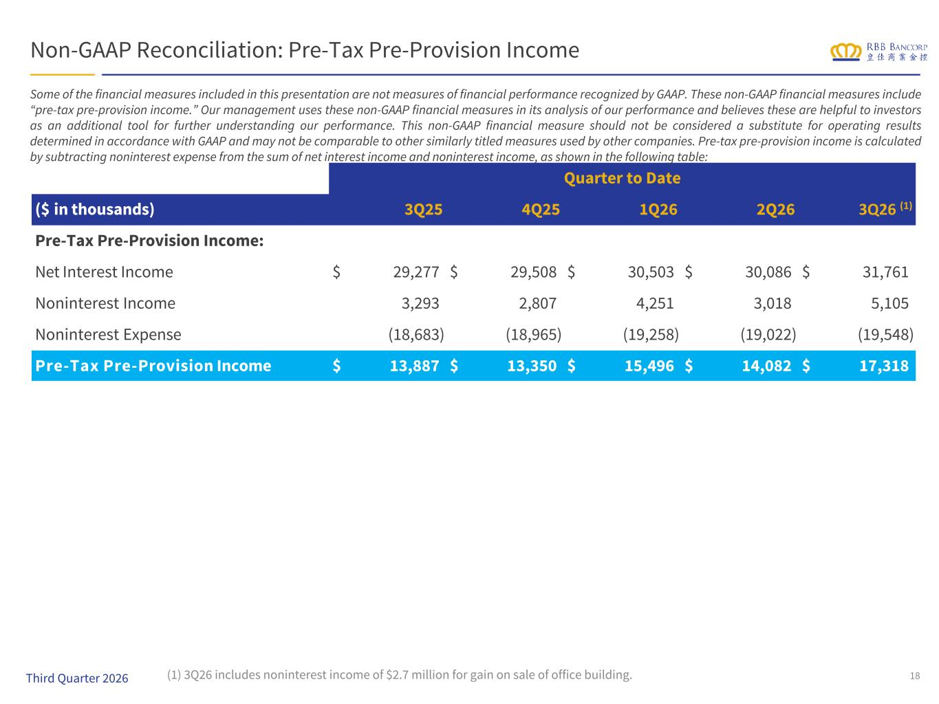
Non-GAAP Reconciliation: Pre-Tax Pre-Provision Income Quarter to Date ($ in thousands) 3Q25 4Q25 1Q26 2Q26 3Q26 (1) Pre-Tax Pre-Provision Income: Net Interest Income $ 29,277 $ 29,508 $ 30,503 $ 30,086 $ 31,761 Noninterest Income 3,293 2,807 4,251 3,018 5,105 Noninterest Expense (18,683) (18,965) (19,258) (19,022) (19,548) Pre-Tax Pre-Provision Income $ 13,887 $ 13,350 $ 15,496 $ 14,082 $ 17,318 18 Some of the financial measures included in this presentation are not measures of financial performance recognized by GAAP. These non-GAAP financial measures include “pre-tax pre-provision income.” Our management uses these non-GAAP financial measures in its analysis of our performance and believes these are helpful to investors as an additional tool for further understanding our performance. This non-GAAP financial measure should not be considered a substitute for operating results determined in accordance with GAAP and may not be comparable to other similarly titled measures used by other companies. Pre-tax pre-provision income is calculated by subtracting noninterest expense from the sum of net interest income and noninterest income, as shown in the following table: Third Quarter 2026 (1) 3Q26 includes noninterest income of $2.7 million for gain on sale of office building.

